This paper is not yet published. Please do not cite or distribute without permission of the authors.

Slipping Past the Test: Compensatory Advantage of Social Background in the Context of Inconsistent Selection Mechanisms in Higher Education

Gordey Yastrebov, Yuliya Kosyakova, Dmitry Kurakin

Abstract
In this paper we analyze how existence of alternative pathways to higher education, which imply different selection mechanisms, affects social inequality in educational attainment. We study this in Russia’s semi-tracked educational system, where higher education can be accessed from both academic and vocational track, but the rules of admission in higher education from each of them are different. Whereas access through academic track is explicitly meritocratic by means of central admission exams aligned with secondary school curriculum, vocational track is generally less selective with regard to student intake, and yet allows less restrictive access to higher education. We argue that this has ambiguous implications for social inequality: on the one hand, meritocratic forms of selection in the academic track disempower advantaged families in their ability to mobilize non-meritocratic resources for success of their children, while, on the other hand, in case of children’s likely failure they encourage them to predate on the opportunities, which were designed to facilitate educational mobility among children of less advantaged families (i.e. pathways enabling access to higher education through vocational programs). We test these conjectures and provide supportive evidence using data from the longitudinal survey Trajectories in Education and Careers.

Keywords: central examinations, compensatory advantage, educational tracking, PISA, TIMSS, relative risk aversion, social inequality

1. Introduction
The organization of secondary education and its connection to the higher education system may have profound implications for inequality in educational and labor market outcomes (Allmendinger 1989; Shavit and Blossfeld 1993; Shavit, Müller, and Tame 1998; Werfhorst and Mijs 2010). This is particularly true of tracked educational systems, in which students are sorted into different educational tracks so that a more efficient match between their aptitude and heterogeneous educational environments can be obtained. However, while it is still a matter of debate whether such systems are more efficient than comprehensive ones in terms of average educational gains (Gamoran 1992; Hanushek and Wößmann 2006; Pekkala Kerr, Pekkarinen, and Uusitalo 2013), there is much more consensus about whether they promote greater inequality in educational outcomes in general and inequalities associated with students’ social background in particular (Gamoran and Mare 1989; Lucas 2001; Meghir and Palme 2005; Oakes 2005; Brunello and Checchi 2007). Thus, even regardless of the possible economic virtues of educational tracking, the potential social inequalities that it promotes can be considered a particularly undesirable side effect.
There are at least two types of policies for coping with inequalities in tracked educational systems. This first involves the introduction of strong principles of meritocratic selection in different types of education and the promotion of corresponding incentives among students, which can be achieved through the standardization of examination procedures and their harmonization with educational curricula (Ayalon and Gamoran 2000; Bol et al. 2014). The second type of policy involves the facilitation of transitions between different types of education, i.e., by providing children and families with the opportunity to reconsider earlier educational choices that would otherwise lead to destined educational careers (Field, Kuczera, and Pont 2007; Holm et al. 2013). In light of educational expansion in many developed nations, boosted by increasing demand for higher education, facilitating transitions from vocational education to higher education is increasingly becoming one of such policies (Bandias, Fuller, and Pfitzner 2011; Pilz 2012).
In this article, we argue that a combination of such policies may have ambiguous implications for inequality in access to higher education. On the one hand, standardized curricula and examinations may disempower advantaged families in their ability to mobilize non-meritocratic resources for the best of their children. On the other hand, they might also encourage them to capture the opportunities that were designed to facilitate educational mobility among children from less advantaged families, such as pathways enabling access to higher education through vocational programs. We test this conjecture in the context of Russia’s educational system, which implements a particular combination of both types of policies. The first one is the Unified State Examination (USE) – a central exit exam – which serves to evaluate the academic aptitude of secondary school graduates (analogous to the American SAT and German Abitur) in correspondence with a highly standardized school curriculum. The USE is also the primary criterion for selection in higher education programs, and it is obligatory for all school graduates seeking to access higher education via the traditional academic track (henceforth, academic pathway). The second feature of Russia’s educational system is the formal possibility of transferring to higher education programs from institutions of upper-level vocational education – so-called technical schools or colleges. These institutions are generally less selective with regard to student intake, yet incidentally, they also allow students to progress to higher education without necessarily facing the challenging USE filter (henceforth, pseudo-academic pathway).
That said, our major focus in this article is the interplay between students’ scholastic abilities and their social background in shaping their educational pathways. Our study contributes to existing literature in two important respects. First, we expand on previous studies reporting the waning of social disparities in educational success among better performing children (Bernardi and Cebolla-Boado 2014), and we reveal a particular mechanism by which upper class families can maintain an advantage in the educational system. More specifically, we lend some support to the theory of compensatory advantage (Bernardi 2014) by showing that upper class families can strategically respond to their children’s lack of academic success by choosing pathways that minimize the risk of status demotion. Second, we contribute to the body of research that has already explored the effect of social background on track mobility and transitions from vocational programs to higher education (cf. Dougherty 1992; Dougherty and Kienzl 2006 in the US; Moodie and Wheelahan 2009 in Australia; Tieben 2011 in the Netherlands; Büchel and Helberger 1995; Bellman and Janik 2010; Hartlaub and Schneider 2012 in Germany; Alexandrov, Tenisheva, and Savelyeva 2015 in Russia; Holm et al. 2013 in Denmark). Yet, in these studies the interactive relationship between children’s social background and their scholastic ability was essentially unrecognized. A single exception is the study of Becker & Hecken (2009), who find that lower performing children from middle class families in Germany are especially predisposed to obtain vocational qualifications before enrolling in higher education. They explain this finding as evidence of ‘an insurance’ motive (Büchel and Helberger 1995) or ‘safety net’ hypothesis (Shavit and Muller 2000): i.e., middle class students choose to pursue vocational education in order to secure at least some level of qualification in the case of their possible failure in higher education. Yet, this finding and the interpretation therein hinges on the context, in which corresponding transitions are analyzed. First, Becker & Hecken (2009) focus exclusively on academic track takers, i.e., students who have proven eligible for higher education by successfully completing the Abitur and thus constitute a highly selective entity. By contrast, in Russia, we compare vocational track takers, who may access higher education without proving their eligibility with the USE, and academic track takers, who necessarily face such a requirement. Second, in Russia, vocational qualifications do not guarantee decent employment prospects because of the weak link between the educational system and the labor market (Gerber 2003; Cheidvasser and Benítez-Silva 2007; Walker 2007; Bühler and Konietzka 2011), and as such, they do not constitute an adequate safety net as they may do in Germany (Shavit and Muller 2000). Hence, a slightly different set of motives might underlie decisions about the track choice and educational transitions of Russian families.
To examine whether and how the existence of pseudo-academic pathways contributes to social inequality in access to higher education in Russia, we use data from the Russian longitudinal survey Trajectories in Education and Careers (TrEC), which focuses on a particular cohort of Russian students (8th grade in 2011). The first big advantage of this dataset is that it allows us to distinguish alternative pathways to higher education rather than focus on traditional transitions from the academic track. The second big advantage is that it contains a battery of high quality proxies for scholastic ability (PISA and TIMSS assessments) before students select different educational tracks. Correspondently, it enables us to evaluate how social background influences these choices depending on the level of students’ aptitude. We find that although pseudo-academic pathways indeed promote social mobility among children from less advantaged backgrounds, their utility with respect to safe-risk access to higher education is especially highly recognized among weakly performing children from more advantaged backgrounds.

2. The context of educational tracking in Russia

2.1 Structure of the educational system in Russia
Russia is classified as a country with a medium degree of educational tracking (Bol et al. 2014). Tracking takes place after 9 years of compulsory education, when students decide whether they will continue education in either the academic or vocational track. Unless students fail the State Final Examination (SFA), which takes place after the 9th grade, this decision is largely voluntary, although students with less aptitude for academically oriented programs may be advised against enrolling in the academic track. Thus, vocational track takers are typically students with a lower academic record (Kosyakova et al. 2016).
Vocational education is provided in vocational schools, and different amounts of time may be required to complete different programs. Until recently, a formal distinction existed between primary vocational schools (1-3 year programs) and secondary vocational schools (2-5 year programs). With the adoption of the new law on education in 2012, this distinction has been abolished in favor of maintaining only secondary vocational education (srednee professional'noe obrazovanie), though this law did not affect the variability of programs regarding the level of qualification provided and their duration. Primary level programs are offered in professional lyceums (professional'nye licei) and typically train students for skilled worker occupations, while secondary level programs are offered in technical schools (tekhnikumy) and colleges (kolledzhi) and typically train students for technical and lower-grade professional occupations.
Students enrolling in the academic track after 9th grade remain in secondary general schools (srednie obscheobrazovatel'nye shkoly) for 2 additional years, where they attain secondary (complete) general education (srednee (polnoe) obschee obrazovanie). The resulting certificate allows students to apply to higher education institutions, making the academic track the most attractive traditional pathway to higher education. In addition, academic track takers retain the option of enrolling in vocational education at any time and thus also enjoy greater freedom of choice.
An important feature of Russia’s educational system is that taking the vocational track does not block the possibility of attaining higher education. Since secondary (complete) general education is currently provided as part of secondary vocational education, students of these schools are formally able to apply for higher education programs. By default, this possibility migrated from the Soviet educational system, where it was in fact part of the socialist policies oriented towards working class people: secondary vocational training and some years of working experience granted workers privileged access to higher education. In the post-Soviet era, the requirement of working experience was waived, thereby allowing more immediate access to higher education from secondary vocational programs. Importantly, this does not imply that such students can enroll in higher education ‘from scratch’: graduates with secondary vocational degrees can enroll immediately in the 2nd or 3rd year of higher education studies depending on the amount of credits recognized from the previous program.
Before the reforms in 2009 (to be introduced shortly below), higher education institutions in Russia administered their own admission examinations. Thus, there were different standards for evaluating students’ aptitude, which were often detached from the standards of typical school exit exams. This was particularly the case with highly selective prestigious universities. Thus, to get admitted, students either had to be exceptionally smart or, as was usually more often the case, must have acquired additional training elsewhere parallel to their school education. The demand for such additional training was usually fulfilled on a private basis, and it was often catered by higher education institutions themselves. The more formal way of obtaining such training was through various preparatory courses provided at the so-called faculties of pre-higher education training (fakul’teti dovuzovskoi podgotovki). However, there was also an informal, more expensive, yet very efficient way, which involved training with private tutors. These tutors were often affiliated with higher education institutions of interest, which could benefit trainees in terms of not only access to more intimate knowledge about the content of exams but also the likely presence of tutors in examination committees in some cases (Klein 2012). Obviously, in such a context, children from upper class families, especially in urban areas, enjoyed an exceptional advantage in access to higher education, since they were the ones who could afford such extracurricular training to greatly increase their chance of admission (Roschina et al. 2006). In the context of sharp social inequalities, which were characteristic of post-Soviet Russia, sharp inequality in the educational system arose (Gerber 2000).

2.2 USE reform and higher education through vocational schools
In 2009, the USE reform was implemented nationwide. The reform has completely standardized the evaluation of students’ academic record upon the completion of secondary (complete) general education by implementing centrally administered exams, which replaced the admission exams previously administered by higher education institutions. On the one hand, this reform was thought to facilitate the selection of better-trained and more competent candidates into advanced educational programs, thereby promoting the efficiency of the educational system. On the other hand, it was thought to remedy the problem of social inequality primarily by rendering most kinds of pre-higher education training irrelevant and subjecting all students to equal admissions criteria.
Although the USE has become the primary filter through which students are selected into higher education in Russia, it has not been universally applied to all kinds of transition into higher education. The strict requirement to submit the USE results for admission applies exclusively to graduates of secondary general schools. Surprisingly, however, no such requirement exists with respect to the applicants with secondary vocational degrees: according to currently existing regulations in Russia, higher education institutions can waive the USE results in favor of locally administered admission procedures for secondary vocational school graduates. Hence, secondary vocational education is a potentially attractive alternative pathway to higher education for students who may seek to avoid the risks and costs associated with the USE. For such students, this pseudo-academic pathway becomes all the more attractive given that secondary vocational schools are usually less selective with regard to student intake than traditional academic programs in secondary general schools, and as such, they also feature a less challenging educational environment. Available qualitative evidence corroborates this intuition, at least to some extent: the principals of secondary vocational schools speculate that it could be the reason behind the disproportionate increase in the number of applications from 9th graders, which the schools experienced immediately after the introduction of the USE (Alexandrov et al. 2015:9).
The potentially powerful influence of the USE reform in reshaping educational pathways can also be inferred from Figure 1. Educational expansion, which was fueled by an ever increasing share of enrolment in higher education, suddenly halted in 2009, when the USE was implemented nationwide. After 2009, this expansion was replaced by increasing enrolment in secondary vocational education, suggesting that the reform has pulled many students away from higher education. To our knowledge, no other reform or process would have explained such sharp discontinuity immediately after 2009. The relatively stable share of enrolment in primary vocational education provides an interesting counterfactual: the state of its attractiveness relative to secondary vocational and higher education remained invariant to the USE reform, because it neither facilitates transitions to other educational programs nor offers a way of bypassing the USE in the manner described above.

Figure 1 about here

The pseudo-academic pathway to higher education remains attractive for other important reasons, some of which have been stated earlier. First, vocational level qualifications may serve as a safety net in case of students’ possible failure in higher education (Büchel and Helberger 1995; Shavit and Muller 2000). Second, the pathway itself does not usually retard the process of educational attainment, and in some cases, it can even spare one year of studies (e.g., if students enroll in the 3rd year of a higher education program after completing a 3-year vocational program after 9th grade).
Quite remarkably, the institutional idiosyncrasy of the Russian educational system, which we described above, appears not simply as a static feature but as one that has been evolving in response to the interests of both educational institutions and families seeking to secure their children’s futures. Alexandrov et al. (2015) identify at least two forms through which this pathway is currently being institutionalized and promoted in the system: 1) the establishment of bilateral institutional agreements between secondary vocational schools and higher educational institutions and 2) the occasional absorption of secondary vocational schools by higher education institutions followed by the reorganization of the former as separate faculties providing secondary vocational training. Incidentally, in the latter context, secondary vocational programs seem to approximate the function previously ascribed to faculties of pre-higher education training, which existed before the introduction of the USE. Namely, such programs offer an alternative pathway to higher education, in which the selection process might follow principles that differ from the meritocratic orientation of the USE.
It must be recognized, however, that the lower selectivity of secondary vocational schools might also be associated with generally lower quality of higher education obtained via pseudo-academic pathways. Often, this tends to be part-time higher education, which is generally considered to be of inferior quality than full-time education in Russia (Alexandrov et al. 2015), and it is also known to yield lower returns on the labor market (Gerber and Schaefer 2004). In addition, students accomplishing vocational schools are less likely to transfer to prestigious higher education institutions than academic track takers (Kosyakova et al. 2016). Yet, although the lower quality of higher educational credentials supplied is a possible downside of pseudo-academic pathways, such credentials maintain a high value in the context of the massive educational expansion in Russia in recent years (Kyui 2016).

3. Educational inequality in Russia: theoretical insights
The idea of persistent inequalities in education is deeply entrenched in the literature, and it has long been established that a certain degree of social inequality is maintained in any educational system (e.g., Shavit and Blossfeld 1993; Blossfeld et al. 2016). Many theories compete for the most general explanation of this phenomenon, but the ones that currently provide the most satisfactory accounts tend to ‘be built up from a model of rational actors operating within an institutional framework’ (Breen and Jonsson 2005:236). Our considerate description of the institutional features of Russia’s educational system anticipates this appeal, and we also trust this to be a fruitful framework.

3.1 The theory of relative risk aversion
One particular theory that has received considerable attention in the study of educational transitions is the theory of relative risk aversion (RRA) (Breen and Goldthorpe 1997). This theory conceptualizes educational decisions to result from a rational calculation of risks and benefits associated with alternative educational strategies. It further recognizes that the same strategies can be differently evaluated by descendants of different socioeconomic groups. The benchmark against which the costs and benefits are calculated is set by strategies enabling status maintenance: avoiding downward mobility is certainly an imperative for families, whereas upward mobility entails additional risks. For instance, upper class children might choose higher education because it prevents their downward mobility, but for them, it is also associated with little relative risk. In turn, the relative risk of the same strategy for the children of lower class parents is much higher (because of economic constraints, the lack of necessary academic culture, etc.) and is likely to outweigh its potential benefits. In other words, the theory predicts that most people prefer to stay on the safe side.
RRA is also general enough to recognize factors that explain possible deviations from the general pattern of status maintenance. For instance, in meritocratic systems, scholastic ability should be an important factor in shaping educational careers, since the risk of failure in more challenging educational environments is lower among smarter kids. Thus, even if children share the same social origin, the option of enrolling in higher levels of education should be less restrictive for smarter children. Nevertheless, scholastic ability affects the subjective evaluation of only certain types of risks associated with different educational careers, whereas the evaluation of other types of risks might still be subject to social background differences. The nature of these other risks might be quite different, ranging from purely economic reasons to cultural and psychological challenges associated with the choice of less habitual pathways.
It is the common ceteris paribus prediction of RRA that social background differences should be present in all kinds of educational transitions, but how can this be reconciled in the context of pseudo-academic pathways to higher education? By virtue of the institutional setup in Russia, this alternative pathway provides a less risky route, because 1) it is less restrictive with respect to children’s scholastic abilities, 2) it allows students to bypass the more challenging admissions rules of the traditional academic pathway, and 3) it secures at least some level of professional qualifications before entry into higher education (similar arguments were laid out by Alexandrov et al. 2015). From the RRA point of view, these attractive features should be of little relevance to the decisions of upper class families, since upper class families would still be more equipped to afford academic pathways than lower class families. In contrast, pseudo-academic pathways should be relatively more attractive for the children from lower class families, as they provide a chance for upward mobility at a relatively lower risk. In other words, pseudo-academic pathways should be more accessible to the descendants of lower social origin, thereby allowing fewer social inequalities relative to the patterns observed in the choice of purely academic and purely vocational pathways. Hence, we would expect that:

The smallest disparities attributed to social background should be observed in pseudo-academic pathways to higher education (‘Social mobility hypothesis I’).

To put it in more specific terms, the hypothesis above implies that the difference between lower and upper class families in the odds of taking pseudo-academic pathways vs either purely academic or purely vocational pathway should be smaller than the corresponding difference in the odds of choosing between purely academic and purely vocational pathways.
We must further emphasize that this hypothesis applies on a ceteris paribus condition, i.e., it asserts the state of disparities on top of the inequality caused by uneven distribution of scholastic ability across different social backgrounds. Thus, we recognize the conceptual distinction introduced by Boudon (1974) by distinguishing between ‘primary’ and ‘secondary’ effects of social background, as well as the possibility that both could be at work in shaping the overall pattern of inequality in educational transitions. Importantly, this distinction leads to another important conjecture. We mentioned that secondary vocational schools are less selective with regard to ability than admissions into the academic track. As such, in facilitating access to higher education, they should also provide less leverage for inequality induced by social disparities in ability (i.e., primary effects of social background). Hence, we could also postulate that:

Pseudo-academic pathways to higher education should be less selective with regard to ability (‘Social mobility hypothesis II’).

We deem labeling our first and second hypotheses as ‘social mobility hypotheses’ appropriate because, if proven to be the case, pseudo-academic pathways could indeed be treated as a mechanism that attenuates inequality in access to higher education.

3.2 The theory of compensatory advantage
Unfortunately, lessons regarding the persistent nature of social inequality temper our social optimism and force us to cast some shadow on the possible discovery of a new social lift. Such a tempered yet theoretically consistent perspective is offered by the theory of the compensatory advantage of social background (CA) (Bernardi 2012, 2014). The CA theory does not contradict but rather complements RRA, as it is based on the same premises of rational choice theory. CA capitalizes on a simple and intuitive insight that the life course trajectories of children from upper class families are usually less dependent on prior negative outcomes. Upper class families are more equipped with resources and information that can be utilized to correct for a false step or exposure to unfavorable circumstances that may harm their children’s futures. By the same logic, upper class families may possess more far-sighted rationality; thus, they may strategically evaluate the risks of possible failure and take preventive measures to minimize them. In sum, CA predicts that whenever a group is exposed to disadvantage, inequality in that group is likely to increase, since individuals from more advantaged backgrounds tend to be more equipped to cope with difficulties.
The lack of scholastic ability and motivation in children, which for whatever reason might occur even among upper class children, could represent a particular case of disadvantage, in which social background might enter as such compensating force. Higher selectivity of academic pathways to higher education would increase the risk of failure for lower performing children from upper class families, especially in the context of the USE filter, and would thus threaten their status maintenance. Upper class families would then be incentivized to devise strategies that could nevertheless secure access to higher education – or at least reduce the risks of failing. In this case, we should first expect social inequality in the chances of attaining higher education to increase at lower levels of scholastic ability. In other words, we expect that:

Social disparities in access to higher education should be negatively associated with levels of ability (‘Social reproduction hypothesis I’).

Although strategies aimed at minimizing the risks of failure due to low scholastic ability might be deployed as part of academic track training (e.g., through lessons with private USE tutors or enrolment in more formal preparatory programs), this is still a risky route, as any persistent lack of ability and motivation also potentially undermines the efficiency of such training. The pseudo-academic pathway represents a more rational strategy in this case, because it spares these risks and yet provides access to higher education. Thus, upper class families should be more willing to consider this as a strategy of status maintenance, especially when the risks of failure via the academic route to higher education become increasingly high. In other words, the pseudo-academic pathway itself becomes a mechanism by which upper class families compensate for their children’s lack of academic aptitude. This leads us to postulate that:

Pseudo-academic pathways to higher education should be more negatively selective regarding ability for children from upper class families than for children from lower class families (‘Social reproduction hypothesis II’).

In this case, we would further expect that the mere existence of pseudo-academic pathways should largely account for the patterns predicted by social reproduction hypothesis I, i.e., greater social disparities in access to higher education at the lower end of the ability distribution. Flipping the argument around, we would expect that the compensatory effect of social background should wane in more meritocratic academic pathways, since families have less control over selection mechanisms in higher education in such contexts. This brings to our final hypothesis:

Social disparities in access to higher education via academic pathways should be less dependent on children’s ability than social disparities in access to higher education via all pathways (‘Social reproduction hypothesis III’).

The last three hypotheses are labeled as ‘social reproduction hypotheses’, because in contrast to our first set of hypotheses, they posit increasing social inequalities owing to the existence of pseudo-academic pathways.

4. Data and variables
To test our hypotheses, we utilize a source of data that uniquely satisfies our research purposes: the longitudinal survey TrEC administered by the Center for Cultural Sociology and Anthropology of Education at the National Research University Higher School of Economics. The survey is based on the TIMSS 2011 sample, which represents the cohort of 8th grade students attending Russian secondary general schools in 2011. The sample has been followed roughly on an annual basis to collect information on the development of student educational careers, as well as various aspects of their participation in the educational system. The big advantage of this dataset is that it features a host of high quality measures of scholastic ability because it is a part of TIMSS and PISA assessments. Importantly, both assessments were carried out before the completion of 9th grade, i.e., before the division into the academic and vocational tracks takes place in Russia. Basic information about the structure of the study and its timeframe is provided in Table 1.

Table 1 about here

The most recent available data come from Wave 5, which was administered in 2016, i.e., at least 4 years after the choice of educational track. For academic track takers, this would amount to being transferred to the 3rd year of higher education studies. For students enrolling in vocational track after 9th grade, this would amount to having accomplished at least 4 years of vocational training. Thus, some of those who chose to enroll in 4-year vocational programs with a view towards higher education should have accomplished their transition by the time of data collection. Pseudo-academic transitions from 5-year vocational programs will nevertheless not be recognized in our analysis.
Another potential problem is posed by sample attrition, which by Wave 5 amounted to 20% of the original TIMSS sample. If attrition is selective with respect to our main outcomes of interest, it could be a source of possible bias in our estimates. To test this possibility, we consider early students’ educational aspirations from the more complete samples. More specifically, we have data on 4,138 respondents of Wave 2, as well as track choice information on an additional 755 non-respondents in Wave 2, which was collected as part of a sample replenishment effort. Hence, our main analyses presented in this article will be conducted using information on real educational transitions (as reported by Wave 5). However, as part of our robustness checks, we complement main analyses with analyses of aspired educational transitions from the earlier but more complete sample (as reported by Wave 2). If significant attrition bias is present, we would expect this to be reflected in substantive differences between the estimation results. This strategy also partly compensates for the lack of data about real transitions to higher education from 5-year vocational programs.
We adopt a very simplistic classification of educational pathways (and aspirations), which simply distinguishes between 4 possible scenarios:

- Academic pathway: academic track after 9th grade → higher education;
- Pseudo-academic pathway: vocational track after 9th grade → secondary vocational education → higher education;
- Vocational pathway: vocational track after 9th grade → vocational education as the ultimate goal;
- Other pathways: all other scenarios, which include various atypical and discontinued pathways (e.g., drop-outs, multiple track switching).

We neglect the distinction between full-time and part-time education, private and state-funded education, and different atypical pathways (e.g., entering vocational schools after completing academic track, dropping out) for the following reasons. First, a more detailed classification would quickly become too confusing and create problems for statistical inference. Second, we deem more detailed classification irrelevant for a more general test of our hypotheses. Third, although we recognize that pseudo-academic pathways to higher education might entail more marginal forms of education (i.e., private and/or part-time studies) and thus provide credentials of significantly lower quality, we assume that this possible loss of quality is taken into account when families make their decisions. The latter argument is particularly relevant for upper class families, because higher education credentials would still be more valuable to them than vocational education credentials regardless of how they were obtained.
To proxy for social background, we use information about the education of parents, because it is the most complete and the most accurately reported measure available in the data. Missing information on the education of parents in the first wave was complemented by information from subsequent surveys, allowing us to impute the majority of missing cases. We distinguish between higher social background (families in which at least one parent has attained higher education) and lower social background (all other families).
To measure scholastic ability and ensure the robustness of our findings, we rely on a host of TIMSS and PISA assessments, all of which were taken before 9th grade. In particular, we have TIMSS science and math scores and PISA science, math and reading scores. In addition, we construct a single synthetic measure by extracting the first principal component from all of the five scores. This synthetic measure explains 78.9% of their joint variance, giving us a slightly more informative measure of scholastic ability than the single components. All ability measures appear as standardized in our analyses.
Finally, we use a modest set of controls. Specifically, we control for 1) gender, because it is likely to confound the relationship between track choice and ability, and 2) the area of residence (at the time of TIMSS assessment), because it is likely to confound the relationship between track choice and social background.

5. Results

5.1 Real and aspired educational transitions
We begin by briefly stating the distribution of real educational transitions as reported in Wave 5 (Table 2, first column). The majority of children – 52% – successfully accomplish the academic track and enter higher education, i.e., they follow the academic pathway. Students taking the vocational pathway account for 27%, and about 10% take the pseudo-academic pathway to higher education. Various atypical and discontinued pathways account for the remaining 12%.

Table 2 about here

However, as we mentioned before, Wave 5 features a rather high level of attrition (20% of the original TIMSS sample). To check whether this may induce any bias, we also provide information on aspired educational transitions and present this distribution for students who were successfully surveyed in Wave 5 (Table 2, second column) and those whose status in Wave 5 remains unknown (Table 2, third column). Table 2 shows that respondents in Wave 5 slightly over-represent those aspiring to take the academic pathway and correspondingly under-represent those aspiring to take the vocational pathway. It also shows that the share of students aspiring to take the pseudo-academic pathway is also underestimated from non-missing cases in Wave 5. Overall, these results suggest that the true distribution of real educational pathways might indeed be slightly different from the one reported in the first column of Table 2, and as such, sample attrition bias is likely. To inspect whether attrition affects the substantive findings, we provide robustness checks of our core results in Section 5.3.

5.1 Alternative pathways to higher education and social mobility
To test our social mobility hypotheses I and II, we model educational pathways as a probability function of scholastic ability, social background and the set of controls. At this stage, we assume only that scholastic ability and social background both independently contribute to the likelihood of different outcomes. We consider a set of 5 mutually exclusive outcomes: i.e., the four classes of pathways described above plus the status of non-response in Wave 5. We model non-responses as a separate outcome rather than dropping them from our analysis to increase the statistical power of our tests and preserve the original TIMSS sample structure. Since we do not assume any implicit ordering of the outcomes, we estimate models using the less restrictive multinomial logistic regression.
Figure 2 presents a grid of graphs illustrating how the probability of following a given pathway (vertical axis) responds to the change in students’ scholastic ability (horizontal axis) and social background (two decorated lines). Each row in the grid corresponds to results from a single model employing a specific ability measure, and each column corresponds to a specific pathway (for convenience, we suppress other pathways and non-response). All estimated models are explicated in Table A.1 in Appendix.

Figure 2 about here

The graphs unambiguously indicate that selection into the academic pathway is strictly positive with regard to ability, whereas selection into the vocational pathway is strictly negative. The relationship between ability and the probability of each of these traditional pathways is statistically significant and is observed for each given ability measure, confirming that this is not a chance result. However, ability-driven selection is certainly not strong enough to completely attenuate the role of social background: e.g., for any given level of ability, the probability of taking the academic pathway is higher for children from more advantaged social backgrounds than for children from less advantaged social backgrounds (the vertical distance between the lines in the graphs). Thus, secondary effects of social background also remain at work.
Looking at the pseudo-academic pathway, we find that social background disparities not only are much smaller than traditional pathways after we control for ability but also are almost indistinguishable here. This result conforms to our social mobility hypothesis I, which predicts the smallest social gap for the pseudo-academic pathway. Figure 2 also unambiguously corroborates our social mobility hypothesis II, which predicts lower selectivity with respect to ability for the pseudo-academic pathway: although there are some weak signs of negative selection (as picked up from the slopes in the corresponding graphs), the relationship is by far less pronounced than it is with the academic and vocational pathways. In sum, our results suggest that the pseudo-academic pathway could indeed facilitate social mobility by reducing both primary and secondary effects of social background in access to higher education.

5.2 Alternative pathways to higher education and social reproduction
Drawing from the CA theory, our social reproduction hypothesis I posits that social disparities in access to higher education should be negatively associated with levels of academic performance. To test this, we model the probability of successful transition to higher education as a function of ability, social background and their interaction. To enable a more intuitive interpretation of our results, we estimate linear probability models, in which the dependent variable is a binary indicator coded as 1 for all traditional and alternative pathways to higher education and 0 for all other transitions. In this step, non-responses in Wave 5 are excluded from the analyses because they cannot be modeled as a separate outcome with this strategy.
The graphs on the left side of Figure 3 display the relationship (estimated models are available in Table A.2 in Appendix). We find that in each of the models employing PISA measures, including the composite measure of ability, the gap due to social background increases in the lower part of the ability distribution (represented by the vertical distance between the lines). In other words, we find an increasing social gap when scholastic ability decreases. This relationship is statistically significant (see Table A.2 for formal test) in all models except the models employing TIMSS measures. We will engage with this inconsistency in the last sub-section. For now, we may conclude that social reproduction hypothesis I is at least partly corroborated by the evidence.

Figure 3 about here

To address social reproduction hypothesis II, we estimate models that are similar in structure to the ones we have used to model educational pathways in Figure 2, except for the interaction term, which now allows the effect of social background to vary along the levels of scholastic ability. Again, to visualize this relationship, we present our results in Figure 4 (estimated models are available in Table A.3 in Appendix).

Figure 4 about here

The patterns for the academic and vocational pathways largely look identical to the ones observed in Figure 2. A peculiar difference is found, however, with regard to the pseudo-academic pathway (central column). Previously, we found few social disparities in the probability of selecting this pathway. In Figure 4, this is no longer the case: in some of our models, particularly the ones employing PISA measures, corresponding probabilities appear to be more sensitive to changes in ability for children from more advantaged backgrounds than for children from less advantaged backgrounds. This result is best observed by considering the extremes of the ability distribution, where the differences in predicted probabilities become statistically significant, as illustrated by the non-overlapping confidence intervals: at higher levels of ability (more than one standard deviation from the mean) children from more (versus less) advantaged backgrounds are less likely to enroll in the track, whereas at lower levels of ability (less than one standard deviation from the mean), the opposite tendency is observed. In general, the inclusion of the interaction term, which elucidates this pattern, leads to a statistically significant improvement in explanatory power in all of the models (according to Wald and likelihood-ratio tests in Table A.3 in Appendix). Thus, the empirical evidence is also largely consistent with our social reproduction hypothesis II.
Our final hypothesis, social reproduction hypothesis III, anticipates that the compensatory effect of social background at lower levels of ability should be less visible in more meritocratic pathways. The graphs on the right side of Figure 3 present the estimation results from models similar to the ones employed for the left-hand side with a single exception: the dependent variable represents successful transition to higher education only via the traditional academic pathway (for the exact models refer to Table A.4). Note that the graphs on the left side of Figure 3 do not distinguish between two different mechanisms of selection into higher education – i.e., meritocratic in the case of the academic pathway (as imposed by the USE requirement) and less meritocratic in the case of the pseudo-academic pathway (as imposed by the possibility of waiving the USE requirement).
Inspection of the graphs on the right side of Figure 3 reveals that secondary effects of social background remain largely stable at any given level of ability, unlike what we observe without distinguishing between both pathways to higher education. Ignoring the results from the TIMSS models, which are again somewhat counter-intuitive, we interpret this result as evidence supporting our social reproduction hypothesis III. In fact, it looks like excluding the pseudo-academic pathway from consideration almost completely rules out the compensatory effect of social background. In other words, the pseudo-academic pathway seems to account for the entire pattern predicted by social reproduction hypothesis I.

5.3 Robustness checks
We enhance the credibility of our findings with several robustness checks. We apply all of our checks to the set of models employed to test social reproduction hypothesis II, since it generalizes the patterns obtained from the rest of our models and corroborates our most important finding.
First, we test whether the results are sensitive to the linear specification of ability effects in our models. We re-estimate the models by substituting continuous ability measures with categorical variables containing quintiles, and we find that this produces similar, albeit less statistically precise patterns (graphic illustration – Figure A.1 in Appendix, full model estimates – Table A.5 in Appendix). However, the reduction in statistical power of the estimates is predictable, since this estimation strategy substantially increases the number of degrees of freedom in the models. Nevertheless, we conclude that linear specification of effects does not invalidate our findings.
Second, we rule out the possibility of bias that we anticipated earlier, i.e., the bias resulting from the sample attrition and selective underrepresentation of students opting for pseudo-academic and vocational pathways. We deal with this issue by re-estimating the models in which real educational transitions are substituted with aspired educational transitions. The results of this estimation do not deviate from the patterns of real educational transitions in a way that would force us to reconsider our findings (graphic illustration – Figure A.2 in Appendix, full model estimates – Table A.6 in Appendix).
Finally, we must engage with the inconsistent results from the models in which scholastic ability is approximated with TIMSS math and science scores. We can offer at least two arguments why using TIMSS measures might enhance rather than weaken the credibility of the corresponding models:

- Higher sample quality: The TIMSS sample is the parent sample for all subsequent waves, and it must therefore provide an unbiased representation of the target cohort;
- Structure of TIMSS assessment: TIMSS assessment is argued to have greater resemblance with Russian secondary general schools’ curriculum than PISA assessment (Tyumeneva, Val’dman, and Carnoy 2014). Hence, it should be more relevant for success in the academic pathway through USE admissions. The latter point is especially important, because the theoretical rationale behind our hypotheses hinges on the USE as an important institutional feature triggering different types of strategies.

To check whether the first argument is valid, we re-estimate the models employing TIMSS measures for ability on a truncated PISA sample (graphic illustration – Figure A.3 in Appendix, full model estimates – Table A.7 in Appendix). This does not affect the previously reported patterns for the TIMSS models, indicating that possible sample bias is not the source of the inconsistency.
To test the plausibility of the second, more substantive argument, we use the USE scores reported by TrEC participants after 11th grade (Wave 4). Table 3 contains correlations between USE scores in Russian and math – two obligatory subjects taken by all secondary general school graduates – and all the 6 measures of scholastic ability employed in our analyses. According to our comparison, the TIMSS measures do not outperform the rest of our measures in terms of their correlations with USE scores. In fact, they are much less predictive of the USE scores in Russian than PISA scores and our composite ability measure. The following tentative explanation can be put forward. PISA assessments, which are said to be less subject specific and less attached to the national school curricula (Tyumeneva et al. 2014), evaluate competencies that are applicable in a wider array of contexts than the more focused and curriculum-based TIMSS assessment. In other words, rather than measuring the degree of mastership of a specific set of skills, PISA might be capturing skills that facilitate learning in the broader sense. As such, PISA assessments might actually be more appropriate as more general proxies of scholastic ability. In any case, we can conclude that the inconsistencies produced by TIMMS scores in our models are not a strong argument against our interpretation of our findings.

Table 3 about here

6. Discussion and conclusions
What do we make of our results? On the one hand, our evidence suggests that in Russia, secondary vocational schools as providers of access to higher education might indeed act as an institutional mechanism that reduces social inequality. In this sense, our results corroborate some previous findings (e.g., Holm et al. 2013; Alexandrov et al. 2015). In particular, we found that compared with the more traditional academic pathway to higher education, pseudo-academic pathways via secondary vocational schools 1) are less selective with regard to ability (thus cutting the leverage for primary effects of social background) and 2) attenuate inequality in access to higher education associated with social background regardless of students’ abilities (i.e., reduce secondary effects of social background). The latter piece of evidence is consistently explained within the framework of RRA (Breen and Goldthorpe 1997): while not offering any particular advantages to upper class children, pseudo-academic pathways entail lower risk for lower class children and may thus influence their demand for this kind of transition.
However, our analyses reveal that this opportunity brings about peculiar side effects, which have gone unrecognized in previous research. While generally reducing social inequality in access to higher education, pseudo-academic pathways also act as a work-around for children from more advantaged backgrounds, for whom they help secure greater access to higher education even if they have an insufficient academic record. The better recognition of this opportunity by children from upper class families is consistent with the theory of CA, according to which ‘upper-class families will deploy all available resources, including nonacademic and nonmeritocratic resources, to minimize the negative consequences of an initial negative outcome and secure educational advantage for their children’ (Bernardi 2014:85). From this perspective, pseudo-academic pathways to higher education in Russia represent a particular mechanism by which upper class families can more effectively achieve their goals and maintain inequality in contexts that threaten their status maintenance. A broader implication of this finding is that policy interventions taken to reduce social inequality via meritocratic principles (such as the USE reform in Russia) incentivize upper class families to circumvent these principles and seek out alternative strategies that might help them maintain their advantage.
Concerning more specific policy implications, our findings reveal a peculiar dilemma. Standardized examinations are often implemented with the purpose of promoting the efficiency of educational systems and fostering the equality of educational opportunity. The inconsistent manner in which they regulate access to higher education through the vocational and academic tracks in Russia definitely undermines the efficiency of Russia’s tracked educational system. However, it also reveals the ambiguity of the consequences for social mobility. On the one hand, applying the same highly meritocratic rules of selection through both tracks might work towards higher equality in allocation decisions, i.e., by blocking the work-around for the lower performing children of upper class families. On the other hand, this would also undermine the premises, on which the vocational track currently serves as a social lift for lower class children by providing relatively easy and safe-risk access to higher education. In terms of reducing social inequalities, blocking pseudo-academic pathways would certainly bring more ‘harm’ than ‘good’ simply because the number of lower performing children from upper class families is much smaller than the number of children from less advantaged families who make use of pseudo-academic pathways.
The goal of efficiency, however, should tip the balance towards more consistent implementation of the USE. Yet, this would pose another potentially serious challenge. In the context that we have described, the survival of a certain group of education providers might actually hinge on the selective application of the USE. This opportunity attracts enrolment, enrolment brings funding, and the involved education providers would thus have a serious stake in maintaining the status quo. Evidence of increasing cooperation between secondary vocational and higher education institutions (Alexandrov et al. 2015) and the continuing existence of the opportunity to avoid the USE even 9 years after the reform should convince one that this challenge is certainly a possibility. We can also take it as a sign of a reinforcing relationship between the institutional context and the structure of social inequality: while it is possible that the latter affects the former, we should not discard the fact that institutions might themselves be adapting to meet the demand for a particular type of strategy of social reproduction.
We would like to recognize certain limitations of our findings. First, we cannot assert that the motive of avoiding the USE and strict meritocratic rules of selection is the only motive that might force lower performing upper class children to use alternative pathways to higher education. According to the ‘safety net’ hypothesis (Büchel and Helberger 1995; Shavit and Muller 2000; Becker and Hecken 2009), such children might opt for vocational qualifications in order to secure at least some level of qualification before pursuing a risky route to higher education. We argued that the safety net hypothesis is less applicable in the Russian context because it hinges on the assumption of the strong tie between the educational system and the labor market (Shavit and Muller 2000), i.e., vocational qualifications have to provide some advantage over higher education in the form of transition to secure labor market positions in order to fulfill the insurance motive. In Russia, vocational level qualifications do not provide such an advantage (Gerber 2003; Cheidvasser and Benítez-Silva 2007; Walker 2007; Bühler and Konietzka 2011). To weigh alternative arguments empirically, additional research is needed. For more conclusive evidence in this regard, future research could compare the distribution of strategies according to ability and social background before and after the implementation of the USE. However, to the best of our knowledge, such data do not exist. An alternative ‘qualitative’ approach could probe deeper into the narratives of students and families about the real motives of behind their decisions. Both could be valuable extensions to our research.
Second, our analysis is limited to a single cohort enjoying perhaps the lowest amount of competition because of the cohort’s sheer size. Students in the TrEC sample belong to the slim generation born in the 1990s, when Russia’s birth rates hit their local historical minimum (Barkalov 2005). Therefore, the patterns that we found might reveal only the tip of the iceberg: as baby boom cohorts born in the early 2000s will flood Russia’s educational system in the nearer future, the competition is likely to increase, and the patterns should become even more visible.
Finally, at this point, we cannot directly assess how successful pseudo-academic pathways are in helping students complete higher education and its returns on the labor market. Existing studies suggest that students with vocational background often interrupt their educational careers in higher education (Brown, Moerkamp, and Voncken 1999) or end up with lower quality higher education (Hoelscher et al. 2008; Moodie and Wheelahan 2009; O’Shea, Lysaght, and Tanner 2012). Such students also tend to spend more time finding adequate employment, and their efforts are not necessarily compensated by higher wages (Büchel and Helberger 1995). In fact, we know that in Russia, pseudo-academic pathways lead to less prestigious higher education (Kosyakova et al., 2015) and less lucrative part-time education (Alexandrov et al. 2015), which might temper both the optimistic and pessimistic implications of pseudo-academic pathways for broader social inequality. Data on school-to-work transitions and early careers should become available in the future waves of the TrEC survey, and they would enable us to shed more light on these issues.

Endnotes

References
Alexandrov, Daniel, Ksenia Tenisheva, and Svetlana Savelyeva. 2015. Safe Mobility: University after Technical College Pathway. Moscow: National Research University Higher School of Economics. Retrieved February 28, 2017.
Allmendinger, Jutta. 1989. “Educational Systems and Labor Market Outcomes.” European Sociological Review 5(3):231–50.
Ayalon, Hanna and Adam Gamoran. 2000. “Stratification in Academic Secondary Programs and Educational Inequality in Israel and the United States.” Comparative Education Review 44(1):54–80.
Bandias, Susan, Don Fuller, and Darius Pfitzner. 2011. “Vocational and Higher Education in Australia: A Need for Closer Collaboration.” Journal of Higher Education Policy and Management 33(6):583–94.
Barkalov, Nicholas B. 2005. “Changes in the Quantum of Russian Fertility During the 1980s and Early 1990s.” Population and Development Review 31(3):545–56.
Becker, Rolf and Anna E. Hecken. 2009. “Why Are Working-Class Children Diverted from Universities?—An Empirical Assessment of the Diversion Thesis.” European Sociological Review 25(2):233–50.
Bellman, L. and F. Janik. 2010. “Abitur and What Next? Reasons for Gaining Double Qualifications in Germany.” Schmollers Jahrbuch 1–18.
Bernardi, Fabrizio. 2012. “Unequal Transitions: Selection Bias and the Compensatory Effect of Social Background in Educational Careers.” Research in Social Stratification and Mobility 30(2):159–174.
Bernardi, Fabrizio. 2014. “Compensatory Advantage as a Mechanism of Educational Inequality A Regression Discontinuity Based on Month of Birth.” Sociology of Education 87(2):74–88.
Bernardi, Fabrizio and Héctor Cebolla-Boado. 2014. “Previous School Results and Social Background: Compensation and Imperfect Information in Educational Transitions.” European Sociological Review 30(2):207–17.
Blossfeld, Hans-Peter, Sandra Buchholz, Jan Skopek, and Moris Triventi, eds. 2016. “Models of Secondary Education and Social Inequality: An International Comparison.” in Models of Secondary Education and Social Inequality: An International Comparison, eduLIFE Lifelong Learning. Edward Elgar Publishing.
Bol, Thijs, Jacqueline Witschge, Herman G.Van de Werfhorst, and Jaap Dronkers. 2014. “Curricular Tracking and Central Examinations: Counterbalancing the Impact of Social Background on Student Achievement in 36 Countries.” Social Forces 92(4):1545–72.
Boudon, Raymond. 1974. Education, Opportunity, and Social Inequality: Changing Prospects in Western Society. John Wiley & Sons Canada, Limited.
Breen, Richard and John H. Goldthorpe. 1997. “Explaining Educational Differentials Towards a Formal Rational Action Theory.” Rationality and Society 9(3):275–305.
Breen, Richard and Jan O. Jonsson. 2005. “Inequality of Opportunity in Comparative Perspective: Recent Research on Educational Attainment and Social Mobility.” Annual Review of Sociology 31(1):223–243.
Brown, Alan, Trudy Moerkamp, and Eva Voncken. 1999. “Facilitating Progression to Higher Education from Vocational Paths.” European Journal of Education 34(2):219–35.
Brunello, Giorgio and Daniele Checchi. 2007. “Does School Tracking Affect Equality of Opportunity? New International Evidence.” Economic Policy 22(52):782–861.
Büchel, F. and C. Helberger. 1995. “Bildungsnachfrage Als Versicherungsstrategie – Der Effekt Eines Zusätzlich Erworbenen Lehrabschlusses Auf Die Beruflichen Startchancen von Hochschulabsolventen.” Mitteilungen Aus Der Arbeitsmarkt- Und Berufsforschung 28(1):32–42.
Bühler, C. and D. Konietzka. 2011. “Institutional Change and the Transition from School to Work in Russia.” Pp. 296–319 in Making the transition: education and labor market entry in Central and Eastern Europe, edited by I. Kogan, C. Noelke, and M. Gebel. Stanford: Stanford University Press.
Cheidvasser, Sofia and Hugo Benítez-Silva. 2007. “The Educated Russian’s Curse: Returns to Education in the Russian Federation during the 1990s.” Labour 21(1):1–41.
Dougherty, Kevin J. 1992. “Community Colleges and Baccalaureate Attainment.” The Journal of Higher Education 63(2):188–214.
Dougherty, Kevin J. and Gregory J. Kienzl. 2006. “It’s Not Enough to Get Through the Open Door: Inequalities by Social Background in Transfer from Community College to Four-Year Colleges.” Teachers College Record 108:289–312.
Field, Simon, Małgorzata Kuczera, and Beatriz Pont. 2007. No More Failures: Ten Steps to Equity in Education. Paris: OECD.
Gamoran, Adam. 1992. “The Variable Effects of High School Tracking.” American Sociological Review 57(6):812–28.
Gamoran, Adam and Robert D. Mare. 1989. “Secondary School Tracking and Educational Inequality: Compensation, Reinforcement, or Neutrality?” American Journal of Sociology 94(5):1146–83.
Gavin, Moodie. 2008. From Vocational To Higher Education: An International Perspective. McGraw-Hill Education (UK).
Gerber, Theodore P. 2000. “Educational Stratification in Contemporary Russia: Stability and Change in the Face of Economic and Institutional Crisis.” Sociology of Education 73(4):219–46.
Gerber, Theodore P. 2003. “Loosening Links? School-to-Work Transitions and Institutional Change in Russia since 1970.” Social Forces 82(1):241–76.
Gerber, Theodore P. and David R. Schaefer. 2004. “Horizontal Stratification of Higher Education in Russia: Trends, Gender Differences, and Labor Market Outcomes.” Sociology of Education 77(1):32–59.
Hanushek, Eric A. and Ludger Wößmann. 2006. “Does Educational Tracking Affect Performance and Inequality? Differences-in-Differences Evidence across Countries.” The Economic Journal 116(510):C63–76.
Hartlaub, Vanessa and Thorsten Schneider. 2012. Educational Choice and Risk Aversion: How Important Is Structural vs. Individual Risk Aversion? Berlin: German Socio-Economic Panel Study.
Hoelscher, Michael, Geoff Hayward, Hubert Ertl, and Harriet Dunbar‐Goddet. 2008. “The Transition from Vocational Education and Training to Higher Education: A Successful Pathway?” Research Papers in Education 23(2):139–51.
Holm, Anders, Mads Meier Jæger, Kristian Bernt Karlson, and David Reimer. 2013. “Incomplete Equalization: The Effect of Tracking in Secondary Education on Educational Inequality.” Social Science Research 42(6):1431–42.
Klein, Eduard. 2012. “Academic Corruption in Russia.” Pp. 225–40 in Informal Relations from Democratic Representation to Corruption: Case studies from Central and Eastern Europe, edited by Z. Mansfeldová and H. Pleines. ibidem Press.
Kosyakova, Yuliya, Gordey Yastrebov, Diana Yanbarisova, and Dmitry Kurakin. 2016. “The Reproduction of Social Inequality within the Russian Educational System.” in Models of Secondary Education and Social Inequality: An International Comparison, eduLIFE Lifelong Learning, edited by H.-P. Blossfeld, S. Buchholz, J. Skopek, and M. Triventi. Edward Elgar Publishing.
Kyui, Natalia. 2016. “Expansion of Higher Education, Employment and Wages: Evidence from the Russian Transition.” Labour Economics 39:68–87.
Lucas, Samuel R. 2001. “Effectively Maintained Inequality: Education Transitions, Track Mobility, and Social Background Effects.” American Journal of Sociology 106(6):1642–90.
Meghir, Costas and Mårten Palme. 2005. “Educational Reform, Ability, and Family Background.” The American Economic Review 95(1):414–24.
Moodie, Gavin and Leesa Wheelahan. 2009. “The Significance of Australian Vocational Education Institutions in Opening Access to Higher Education.” Higher Education Quarterly 63(4):356–70.
Oakes, Jeannie. 2005. Keeping Track: How Schools Structure Inequality. 2nd ed. Yale University Press.
O’Shea, Sarah, Pauline Lysaght, and Kathleen Tanner. 2012. “Stepping into Higher Education from the Vocational Education Sector in Australia: Student Perceptions and Experiences.” Journal of Vocational Education & Training 64(3):261–77.
Pekkala Kerr, Sari, Tuomas Pekkarinen, and Roope Uusitalo. 2013. “School Tracking and Development of Cognitive Skills.” Journal of Labor Economics 31(3):577–602.
Pilz, Matthias, ed. 2012. The Future of Vocational Education and Training in a Changing World. Wiesbaden: Springer.
Shavit, Yossi and Hans-Peter Blossfeld, eds. 1993. Persistent Inequality: Changing Educational Attainment in Thirteen Countries. Westview Press.
Shavit, Yossi and Walter Muller. 2000. “Vocational Secondary Education: Where Diversion and Where Safety Net?” European Societies 2(1):29–50.
Shavit, Yossi, Walter Müller, and Clare Tame. 1998. From School to Work: A Comparative Study of Educational Qualifications and Occupational Destinations. Clarendon Press.
Tieben, Nicole. 2011. “Parental Resources and Relative Risk Aversion in Intra-Secondary Transitions: A Trend Analysis of Non-Standard Educational Decision Situations in the Netherlands.” European Sociological Review 27(1):31–42.
Walker, Charles. 2007. “Navigating a ‘zombie’ System: Youth Transitions from Vocational Education in post‐Soviet Russia.” International Journal of Lifelong Education 26(5):513–31.
Van de Werfhorst, Herman G. and Jonathan J. B. Mijs. 2010. “Achievement Inequality and the Institutional Structure of Educational Systems: A Comparative Perspective.” Annual Review of Sociology 36(1):407–28.
Roschina, Yana, David Konstantinovskiy, Dmitry Kurakin, and Victor Vakhshtain. 2006. Dostupnost’ kachestvennogo srednego obrazovaniya v Rossii: vozmozhnosti i ogranicheniya [Access to Quality Secondary Education in Russia: Possibilities and Limitations]. Moscow: Logos.
Tyumeneva Yuliya, Igor Val’dman, and Martin Carnoy. 2014. “Chto dayut predmetnye znaniya dlya umeniya primenyat’ ikh v novom kontekste. Pervye rezyl’taty sravnitel’nogo analiza TIMSS-2011 i PISA-2012. [What Does Subject Knowledge Give for Its Applying in New Context. The First Results from Studies TIMSS-2011 and PISA‑2012]” Voprosy obrazovaniya [Educational Studies] (1):8–24.

Figures
Figure 1. The structure of enrolment in vocational and higher education in Russia and the USE reform

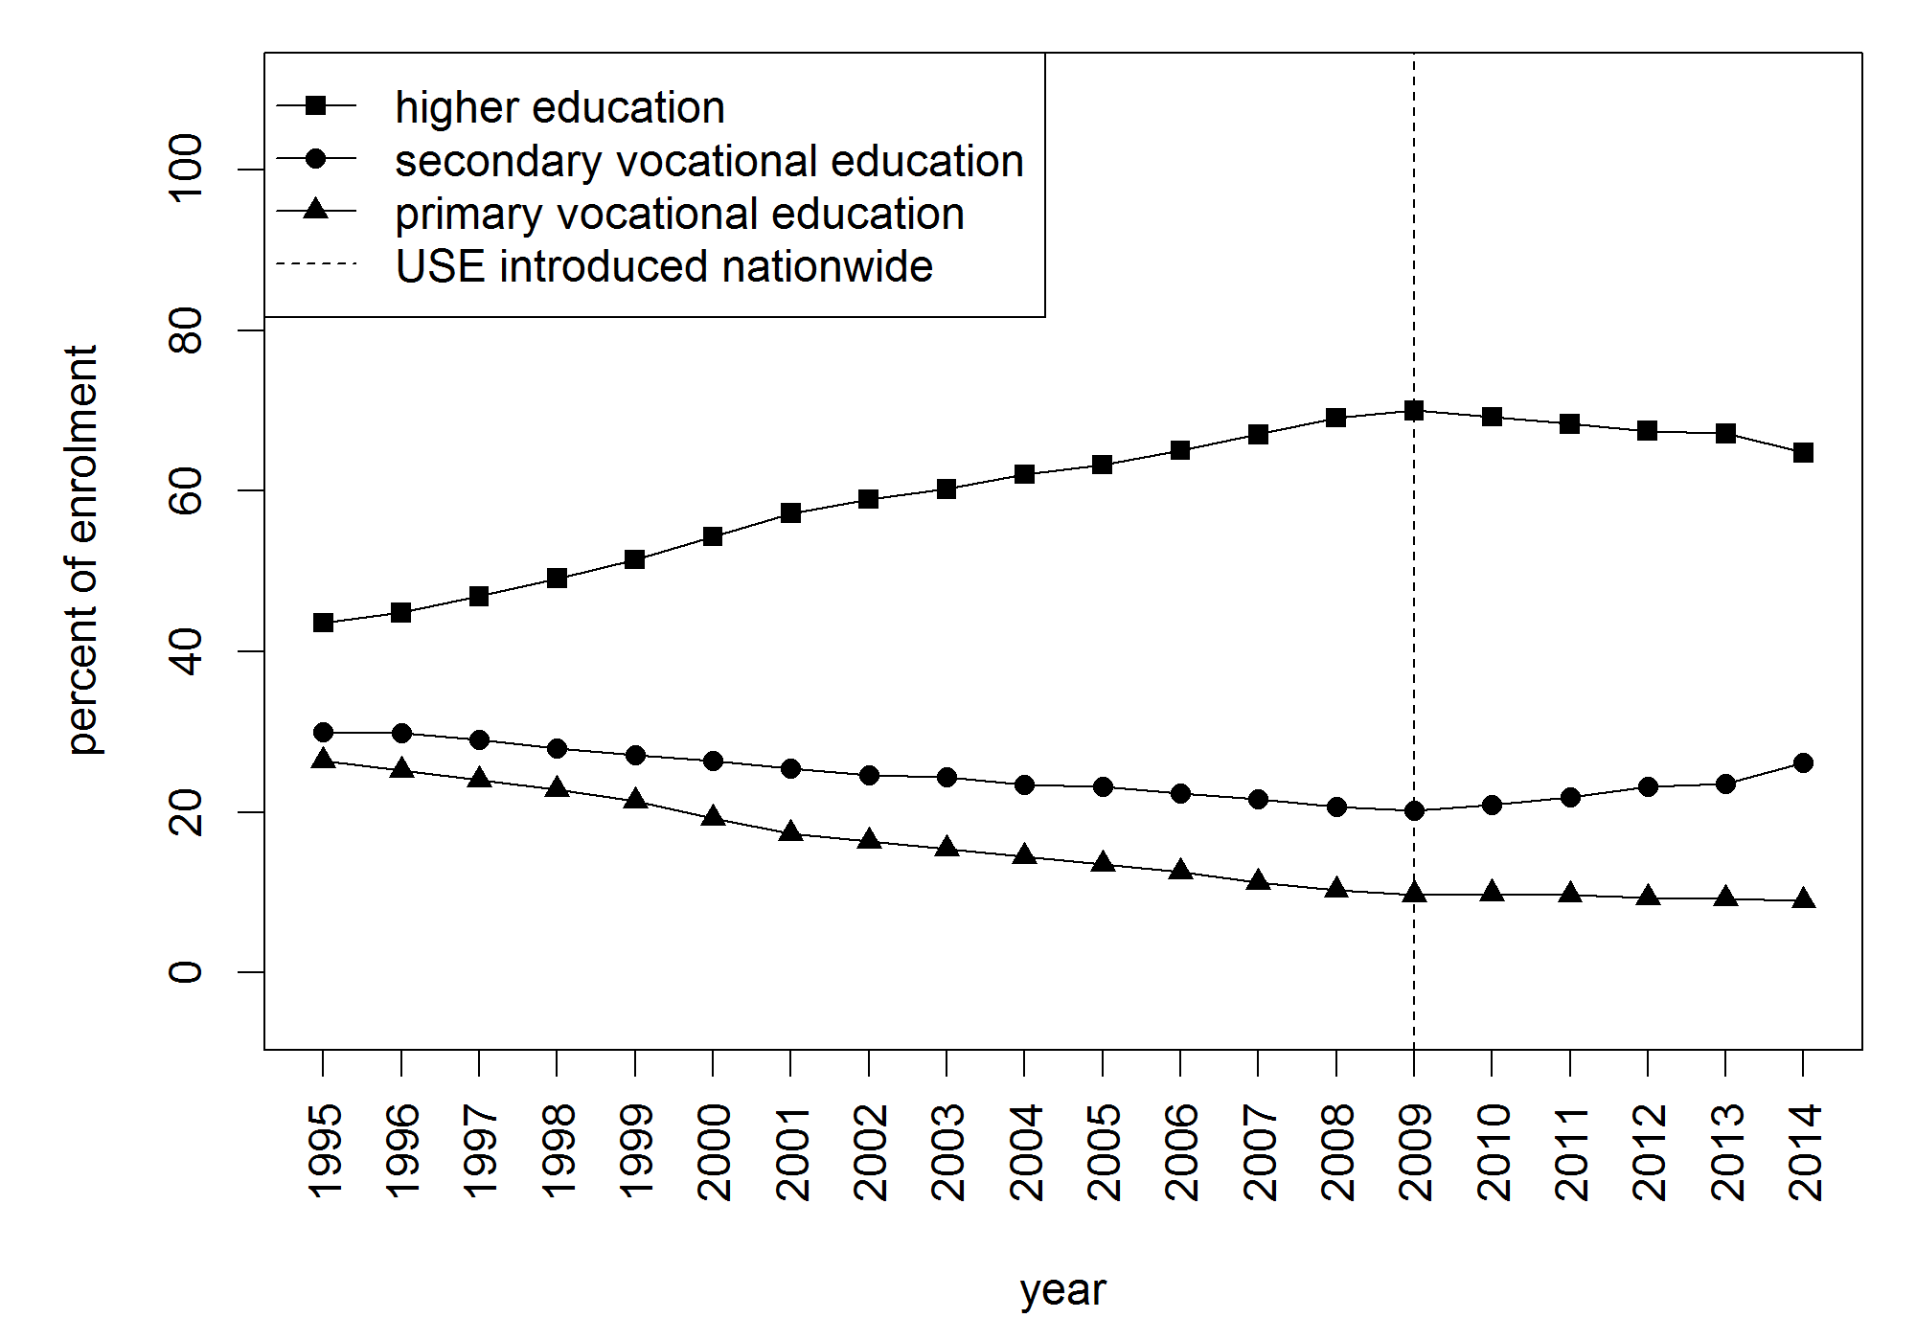
Note: Proportions calculated as the total number of students enrolled in a given educational program in a given year divided by the total number of students enrolled in all of the three programs in that same year. Source: Russia’s Federal State Statistics Service.

Figure 2. Predicted probabilities of real educational pathways as functions of scholastic ability and social background

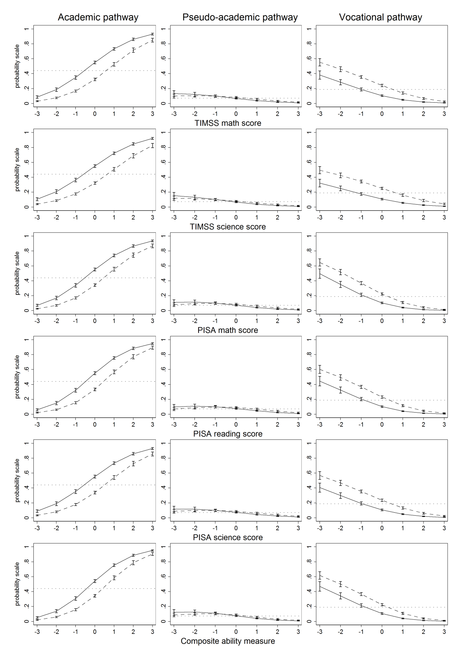
Notes: Solid lines – higher social background; dashed lines – lower social background. Horizontal dotted lines – unconditional (baseline) probabilities of corresponding outcomes. Vertical spreads denote 95% confidence intervals. Model estimates are available in Table A.1 in Appendix. Source: TrEC; own calculations.

Figure 3. Predicted probabilities of educational outcomes as functions of scholastic ability and social background

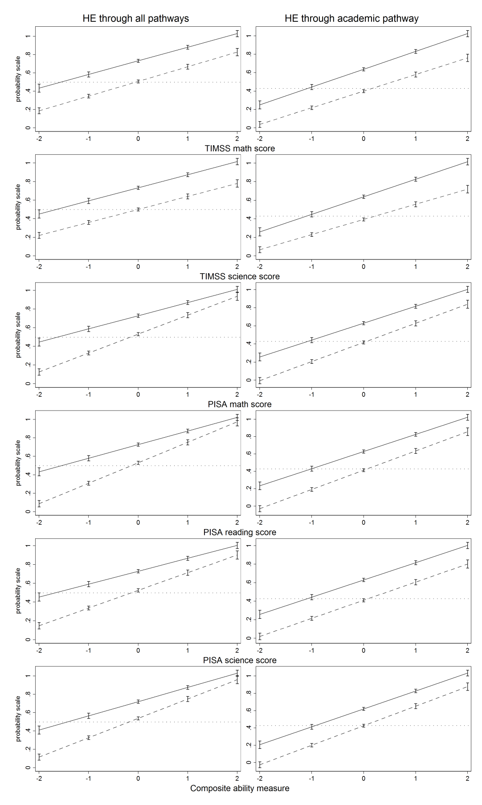
Notes: Solid lines – higher social background; dashed lines – lower social background. Horizontal dotted lines – unconditional (baseline) probabilities of corresponding outcomes. Vertical spreads denote 95% confidence intervals. Model estimates are available in Table A.2 (left side graphs) and Table A.4 (right side graphs) in Appendix. Source: TrEC; own calculations.
Figure 4. Predicted probabilities of real educational pathways as functions of scholastic ability and social background and their interaction

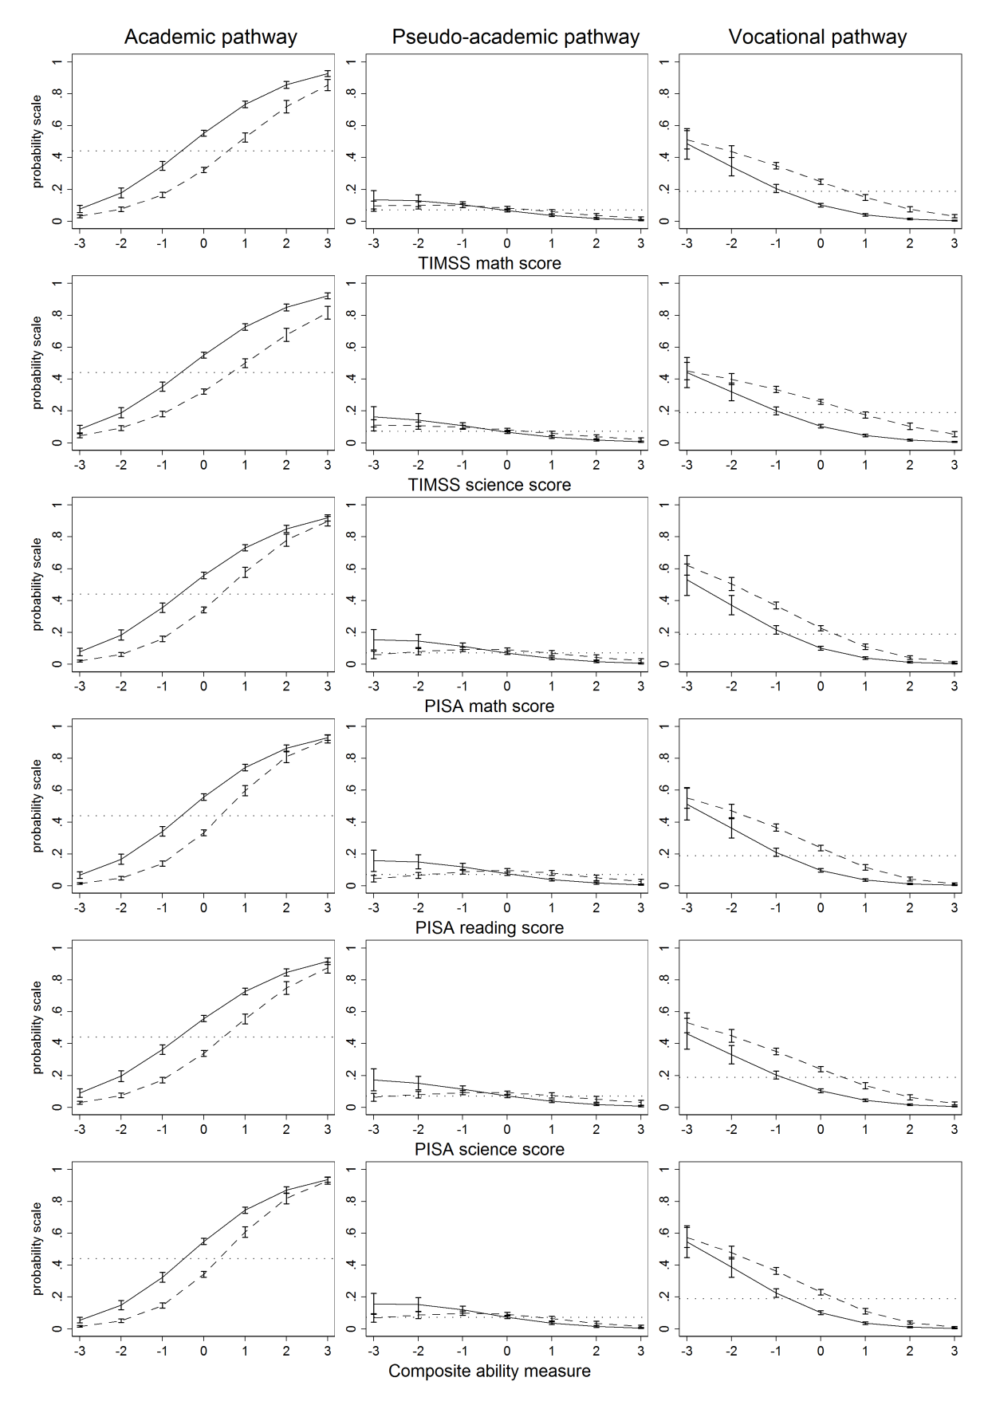

Notes: Solid lines – higher social background; dashed lines – lower social background. Horizontal dotted lines – unconditional (baseline) probabilities of corresponding outcomes. Vertical spreads denote 95% confidence intervals. Model estimates are available in Table A.3 in Appendix.
Source: TrEC; own calculations.

Figure A.1. Predicted probabilities of real educational pathways as functions of scholastic ability (quintiles) and social background

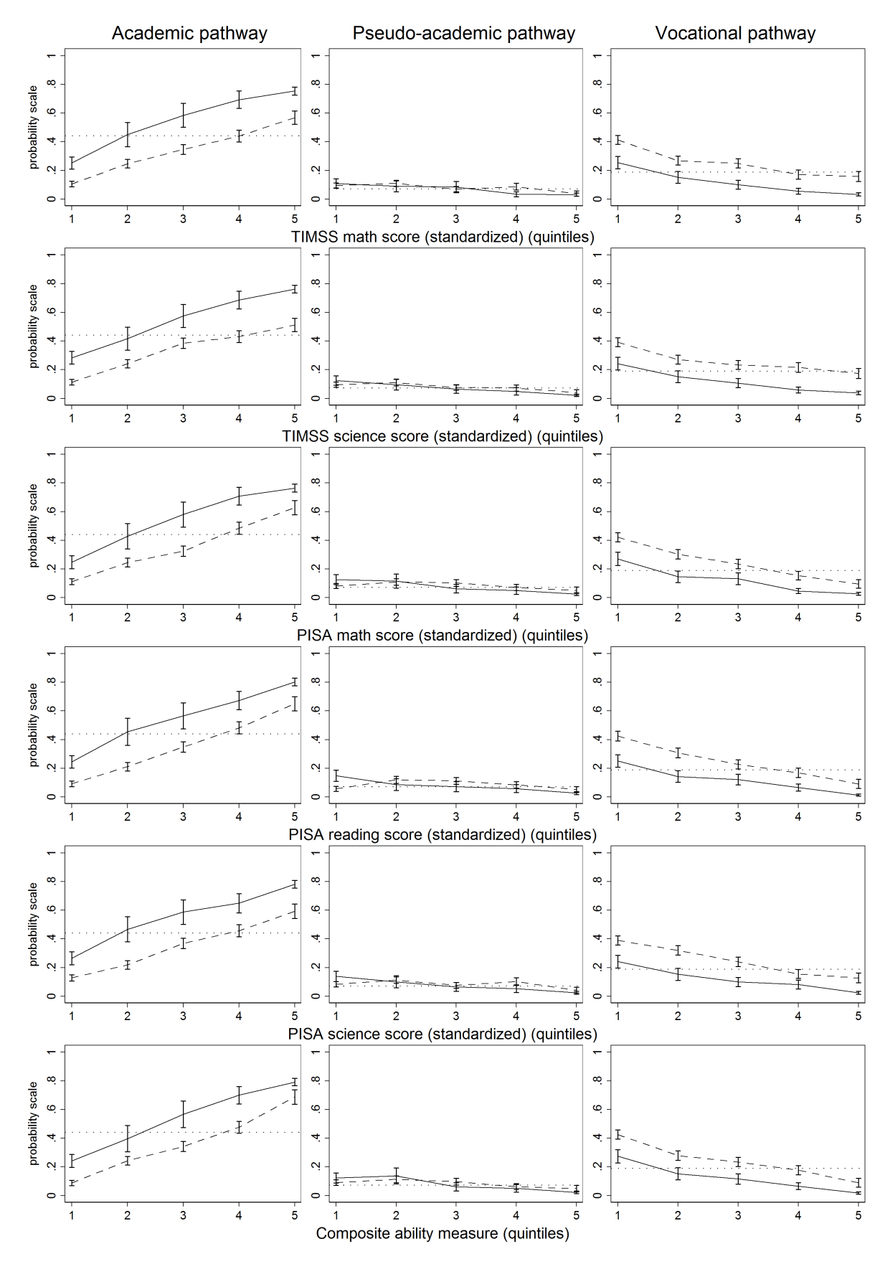

Notes: Solid lines – higher social background; dashed lines – lower social background. Horizontal dotted lines – unconditional (baseline) probabilities of corresponding outcomes. Vertical spreads denote 95% confidence intervals. Model estimates are available in Table A.5 in Appendix. Source: TrEC; own calculations.

Figure A.2. Predicted probabilities of aspired educational pathways as functions of scholastic ability and social background

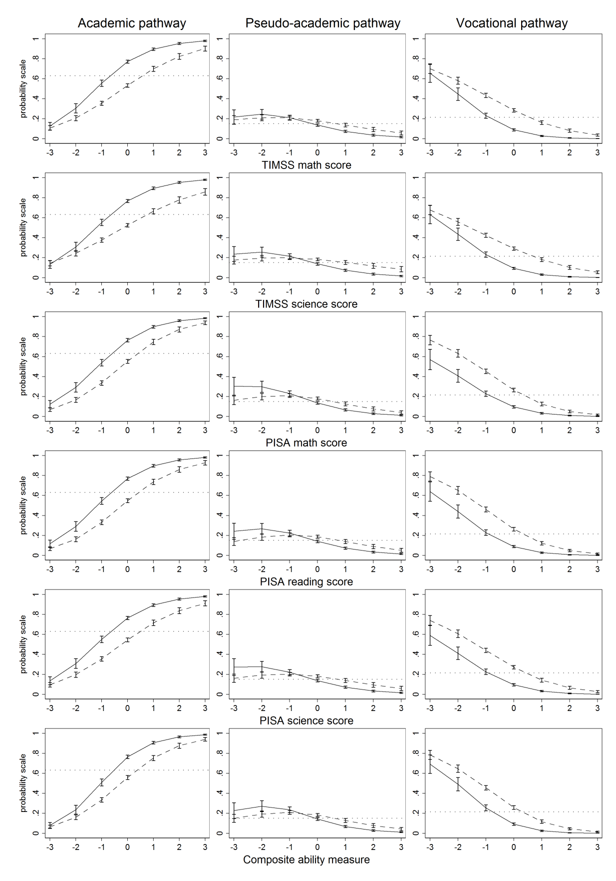

Notes: Solid lines – higher social background; dashed lines – lower social background. Horizontal dotted lines – unconditional (baseline) probabilities of corresponding outcomes. Vertical spreads denote 95% confidence intervals. Model estimates are available in Table A.6 in Appendix. Source: TrEC; own calculations.

Figure A.3. Predicted probabilities of real educational pathways as functions of scholastic ability and social background (PISA sample)

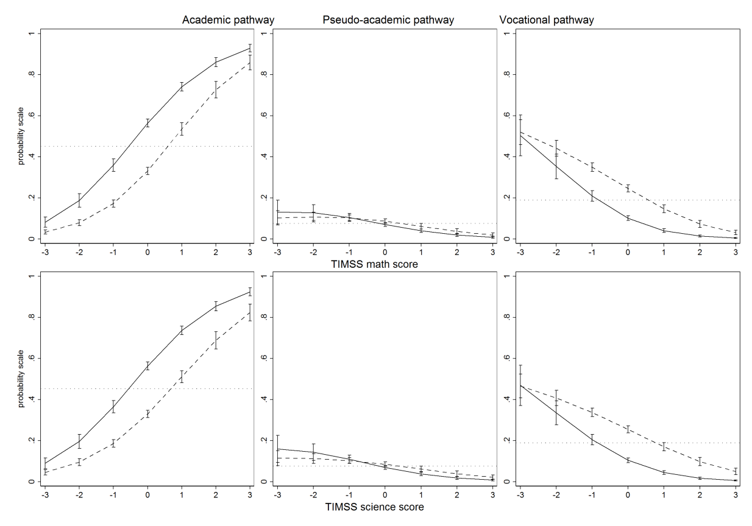

Notes: Solid lines – higher social background; dashed lines – lower social background. Horizontal dotted lines – unconditional (baseline) probabilities of corresponding outcomes. Vertical spreads denote 95% confidence intervals. Model estimates are available in Table A.7 in Appendix. Source: TrEC; own calculations.

Tables
Table 1. The structure of the Russian panel study Trajectories in Education and Careers

Waves | Time of data collection | N¹⁾ | Expected student status in education²⁾
 |  |  | Academic track | Vocational track
TIMSS | Spring  2011 | 4,893 | 8th grade (no tracking) | 8th grade (no tracking)
TrEC Wave 1 | Winter-Spring 2012 | 3,827 | 9th grade (no tracking) | 9th grade (no tracking)
PISA | Spring  2012 | 4,399 | 9th grade (no tracking) | 9th grade (no tracking)
TrEC Wave 2 | Autumn-Winter  2013 | 4,138 | 11th grade | 2nd year in VE
TrEC Wave 3 | Spring-Summer 2014 | 4,239 | 11th grade | 2nd year in VE
TrEC Wave 4 | Autumn  2015 | 3,618 | 2nd year in VE | 4th year in VE
TrEC Wave 5 | Autumn  2016 | 3,866 | 3rd year in HE | 5th year in VE
Notes: HE = higher education. VE = vocational education. 1) Sample size only includes cases matched to the original TIMSS sample. 2) Expected status at the time of survey.

Table 2. Real and aspired educational transitions of students

Educational pathway | Real transitions in Wave 5 ¹⁾ | Aspired transitions  reported in Wave 2 ²⁾
 |  | as percent of respondents  in Wave 5 | as percent of  non-respondents  in Wave5
Academic pathway | 51.6% | 66.0% | 46.4%
Pseudo-academic pathway | 9.8% | 14.8% | 18.0%
Vocational pathway | 26.9% | 18.4% | 32.9%
Other pathways | 11.8% | 0.8% | 2.7%
Total | 100.0% | 100.0% | 100.0%
Observations | 4,752 | 3,799 | 953
Notes: 1) Percentages weighted using longitudinal weights for Wave 5. 2) Percentages weighted using TIMSS original sample weights. Source: TrEC; own calculations.

Table 3. Correlations between USE, TIMSS and PISA scores

 | USE Russian score | USE math score
TIMSS math score | 0.489 | 0.600
TIMSS science score | 0.471 | 0.495
PISA math score | 0.514 ²⁾ | 0.590 ²⁾
PISA reading score | 0.581 ^{1),2)} | 0.509 ¹⁾
PISA science score | 0.529 ^{1),2)} | 0.539 ^{1),2)}
Composite ability measure | 0.588 ^{1),2)} | 0.622 ²⁾
N | 4,308 | 4,308
Notes: 1) Statistically significant difference at 5% confidence level with corresponding correlation for TIMMS math score. 2) Statistically significant difference at 5% confidence level with corresponding correlation for TIMMS science score. Source: TrEC; own calculations.

Table A.1. Multinomial regression models of educational pathways (vocational pathway as baseline outcome)

 | (1) | (2) | (3) | (4) | (5) | (6)
 | TIMSS math score | TIMSS science score | PISA math score | PISA reading score | PISA science score | Composite ability measure
Academic pathway
Higher social background | 1.410*** | 1.435*** | 1.291*** | 1.325*** | 1.324*** | 1.241***
 | (0.097) | (0.096) | (0.103) | (0.102) | (0.101) | (0.103)
Ability measure | 1.074*** | 0.944*** | 1.244*** | 1.233*** | 1.083*** | 1.307***
 | (0.052) | (0.050) | (0.057) | (0.058) | (0.055) | (0.058)
Constant | –0.170 | –0.260** | –0.119 | 0.250* | –0.137 | 0.021
 | (0.090) | (0.088) | (0.095) | (0.099) | (0.094) | (0.097)
Pseudo-academic pathway
Higher social background | 0.685*** | 0.728*** | 0.629*** | 0.640*** | 0.661*** | 0.635***
 | (0.139) | (0.139) | (0.144) | (0.144) | (0.144) | (0.144)
Ability measure | 0.237*** | 0.120 | 0.425*** | 0.416*** | 0.315*** | 0.370***
 | (0.071) | (0.069) | (0.077) | (0.078) | (0.075) | (0.077)
Constant | –1.989*** | –2.076*** | –1.864*** | –1.758*** | –1.929*** | –1.847***
 | (0.149) | (0.149) | (0.153) | (0.160) | (0.153) | (0.156)
Other unclassified pathways
Higher social background | 0.412** | 0.438*** | 0.419** | 0.487*** | 0.465*** | 0.430**
 | (0.130) | (0.130) | (0.135) | (0.134) | (0.135) | (0.135)
Ability measure | 0.359*** | 0.255*** | 0.504*** | 0.318*** | 0.328*** | 0.426***
 | (0.064) | (0.062) | (0.070) | (0.071) | (0.068) | (0.070)
Constant | –0.629*** | –0.702*** | –0.570*** | –0.562*** | –0.653*** | –0.550***
 | (0.108) | (0.107) | (0.114) | (0.123) | (0.114) | (0.117)
Case missing in NP Wave 5
Higher social background | 0.689*** | 0.712*** | 0.589*** | 0.624*** | 0.624*** | 0.592***
 | (0.105) | (0.105) | (0.111) | (0.111) | (0.111) | (0.111)
Ability measure | 0.298*** | 0.219*** | 0.467*** | 0.384*** | 0.334*** | 0.418***
 | (0.052) | (0.051) | (0.058) | (0.059) | (0.056) | (0.058)
Constant | –0.300** | –0.364*** | –0.265** | –0.196 | –0.335*** | –0.237*
 | (0.094) | (0.093) | (0.101) | (0.107) | (0.100) | (0.103)
LR χ² | 1372.4*** | 1282.3*** | 1348.7*** | 1334.2*** | 1245.2*** | 1435.7***
Pseudo-R² | 0.103 | 0.096 | 0.111 | 0.110 | 0.103 | 0.118
df | 20 | 20 | 20 | 20 | 20 | 20
N | 4,711 | 4,711 | 4,308 | 4,308 | 4,308 | 4,308
Notes: All models include controls for sex and TIMSS residence area (suppressed in tables). Main values are logit coefficients. Standard errors provided in parentheses. Source: TrEC; own calculations. * p < 0.05, ** p < 0.01, *** p < 0.001

Table A.2. Linear probability models for enrolment in higher education through all pathways

 | (1) | (2) | (3) | (4) | (5) | (6)
 | TIMSS math score | TIMSS science score | PISA math score | PISA reading score | PISA science score | Composite ability measure
Higher social background | 0.225*** | 0.233*** | 0.196*** | 0.197*** | 0.204*** | 0.183***
 | (0.015) | (0.015) | (0.015) | (0.015) | (0.015) | (0.015)
Ability measure | 0.160*** | 0.140*** | 0.202*** | 0.222*** | 0.188*** | 0.211***
 | (0.010) | (0.010) | (0.011) | (0.011) | (0.011) | (0.011)
Higher social background x Ability measure | –0.012 | 0.001 | –0.062*** | –0.074*** | –0.051*** | –0.056***
 | (0.015) | (0.015) | (0.015) | (0.015) | (0.015) | (0.015)
Constant | 0.392*** | 0.379*** | 0.407*** | 0.469*** | 0.405*** | 0.433***
 | (0.015) | (0.015) | (0.015) | (0.016) | (0.015) | (0.015)
F | 196.2*** | 179.0*** | 200.1*** | 209.4*** | 185.5*** | 214.7***
R² | 0.238 | 0.222 | 0.255 | 0.264 | 0.241 | 0.269
df | 6 | 6 | 6 | 6 | 6 | 6
N | 3,772 | 3,772 | 3,505 | 3,505 | 3,505 | 3,505
Notes: All models include controls for sex and TIMSS residence area (suppressed in tables). Main values are OLS regression coefficients. Standard errors provided in parentheses. Source: TrEC; own calculations. * p < 0.05, ** p < 0.01, *** p < 0.001

Table A.3. Multinomial regression models of educational pathways with interaction term (vocational pathway as baseline outcome)

 | (1) | (2) | (3) | (4) | (5) | (6)
 | TIMSS math score | TIMSS science score | PISA math score | PISA reading score | PISA science score | Composite ability measure
Academic pathway
Higher social background | 1.477*** | 1.492*** | 1.336*** | 1.410*** | 1.377*** | 1.324***
 | (0.102) | (0.100) | (0.110) | (0.110) | (0.106) | (0.111)
Ability measure | 1.031*** | 0.865*** | 1.299*** | 1.303*** | 1.097*** | 1.346***
 | (0.066) | (0.063) | (0.077) | (0.079) | (0.073) | (0.078)
Ability measure x Higher social background | 0.175  (0.109) | 0.264*  (0.105) | –0.057  (0.118) | –0.045  (0.119) | 0.032  (0.114) | 0.007  (0.121)
Constant | –0.195* | –0.284** | –0.134 | 0.223* | –0.157 | –0.008
 | (0.090) | (0.088) | (0.096) | (0.100) | (0.094) | (0.098)
Pseudo-academic pathway
Higher social background | 0.737*** | 0.767*** | 0.599*** | 0.660*** | 0.646*** | 0.646***
 | (0.146) | (0.145) | (0.152) | (0.150) | (0.150) | (0.153)
Ability measure | 0.222* | 0.111 | 0.520*** | 0.543*** | 0.415*** | 0.432***
 | (0.090) | (0.087) | (0.101) | (0.102) | (0.098) | (0.100)
Ability measure x Higher social background | 0.107  (0.149) | 0.108  (0.144) | –0.185  (0.157) | –0.226  (0.155) | –0.179  (0.153) | –0.087  (0.157)
Constant | –2.002*** | –2.083*** | –1.836*** | –1.743*** | –1.906*** | –1.834***
 | (0.150) | (0.150) | (0.154) | (0.160) | (0.154) | (0.157)
Other unclassified pathways
Higher social background | 0.475*** | 0.514*** | 0.452** | 0.569*** | 0.519*** | 0.511***
 | (0.135) | (0.134) | (0.143) | (0.145) | (0.142) | (0.145)
Ability measure | 0.329*** | 0.187* | 0.463*** | 0.241** | 0.273** | 0.351***
 | (0.077) | (0.074) | (0.088) | (0.087) | (0.085) | (0.087)
Ability measure x Higher social background | 0.136  (0.138) | 0.265*  (0.135) | 0.121  (0.147) | 0.230  (0.144) | 0.170  (0.143) | 0.229  (0.147)
Constant | –0.650*** | –0.735*** | –0.589*** | –0.602*** | –0.680*** | –0.591***
 | (0.110) | (0.108) | (0.116) | (0.126) | (0.116) | (0.120)
Case missing in NP Wave 5
Higher social background | 0.783*** | 0.796*** | 0.643*** | 0.733*** | 0.700*** | 0.693***
 | (0.112) | (0.109) | (0.121) | (0.122) | (0.119) | (0.122)
Ability measure | 0.188** | 0.119 | 0.355*** | 0.222** | 0.206** | 0.279***
 | (0.063) | (0.061) | (0.074) | (0.073) | (0.071) | (0.073)
Ability measure x Higher social background | 0.332**  (0.113) | 0.331**  (0.109) | 0.260*  (0.122) | 0.391**  (0.120) | 0.315**  (0.119) | 0.350**  (0.123)
Constant | –0.353*** | –0.408*** | –0.311** | –0.274* | –0.389*** | –0.306**
 | (0.096) | (0.094) | (0.103) | (0.110) | (0.103) | (0.106)
LR χ² | 1381.7*** | 1293.2*** | 1362.7*** | 1361.9*** | 1260.6*** | 1452.4***
Pseudo-R² | 0.104 | 0.097 | 0.112 | 0.112 | 0.104 | 0.120
df | 24 | 24 | 24 | 24 | 24 | 24
N | 4,711 | 4,711 | 4,308 | 4,308 | 4,308 | 4,308
χ² for the Wald test of the interaction effect | 9.243 | 10.814* | 13.924** | 27.393*** | 15.390** | 16.522**
χ² for the Likelihood-ratio test of the interaction effect | 9.322 | 10.937* | 13.996** | 27.675*** | 15.490** | 16.637**
Notes: All models include controls for sex and TIMSS residence area (suppressed in tables). Main values are logit coefficients. Standard errors provided in parentheses. Standard errors provided in parentheses. Source: TrEC; own calculations. * p < 0.05, ** p < 0.01, *** p < 0.001.

Table A.4. Linear probability models for enrolment in higher education through academic pathway

 | (1) | (2) | (3) | (4) | (5) | (6)
 | TIMSS math score | TIMSS science score | PISA math score | PISA reading score | PISA science score | Composite ability measure
Higher social background | 0.238*** | 0.245*** | 0.212*** | 0.215*** | 0.219*** | 0.194***
 | (0.015) | (0.015) | (0.015) | (0.015) | (0.015) | (0.015)
Ability measure | 0.181*** | 0.164*** | 0.211*** | 0.221*** | 0.196*** | 0.226***
 | (0.010) | (0.010) | (0.011) | (0.011) | (0.011) | (0.011)
Higher social background x Ability measure | 0.013 | 0.026 | –0.024 | –0.024 | –0.009 | –0.019
 | (0.015) | (0.015) | (0.015) | (0.015) | (0.015) | (0.015)
Constant | 0.339*** | 0.325*** | 0.346*** | 0.413*** | 0.345*** | 0.377***
 | (0.015) | (0.015) | (0.015) | (0.016) | (0.015) | (0.015)
F | 224.7*** | 208.6*** | 220.8*** | 223.9*** | 205.2*** | 247.3***
R² | 0.264 | 0.249 | 0.275 | 0.277 | 0.260 | 0.298
df | 6 | 6 | 6 | 6 | 6 | 6
N | 3,772 | 3,772 | 3,505 | 3,505 | 3,505 | 3,505
Notes: All models include controls for sex and TIMSS residence area (suppressed in tables). Main values are OLS regression coefficients. Standard errors provided in parentheses. Source: TrEC; own calculations. * p < 0.05, ** p < 0.01, *** p < 0.001

Table A.5. Multinomial regression models of real educational pathways with interaction term (vocational pathway as baseline outcome, ability measures as quintiles)

 | (1) | (2) | (3) | (4) | (5) | (6)
 | TIMSS math score | TIMSS science score | PISA math score | PISA reading score | PISA science score | Composite ability measure
Academic pathway
Higher social background | 1.390***  (0.218) | 1.444***  (0.216) | 1.279***  (0.228) | 1.510***  (0.229) | 1.242***  (0.223) | 1.483***  (0.236)
Ability measure – 2nd quintile | 1.315***  (0.179) | 1.165***  (0.176) | 1.152***  (0.182) | 1.166***  (0.196) | 0.760***  (0.180) | 1.476***  (0.194)
... 3rd quintile) | 1.742***  (0.179) | 1.803***  (0.177) | 1.708***  (0.189) | 1.966***  (0.196) | 1.584***  (0.182) | 2.011***  (0.196)
... 4th quintile | 2.380***  (0.199) | 1.996***  (0.189) | 2.566***  (0.206) | 2.597***  (0.214) | 2.268***  (0.204) | 2.635***  (0.209)
... 5th quintile | 2.726***  (0.214) | 2.400***  (0.208) | 3.327***  (0.259) | 3.506***  (0.277) | 2.728***  (0.237) | 3.719***  (0.283)
Higher social background x 2nd quintile | –0.181  (0.294) | –0.281  (0.293) | 0.063  (0.308) | 0.031  (0.312) | 0.300  (0.305) | –0.351  (0.316)
... x 3rd quintile | 0.085  (0.297) | –0.216  (0.295) | –0.073  (0.305) | –0.393  (0.305) | 0.143  (0.307) | –0.242  (0.313)
... x 4th quintile | 0.228  (0.323) | 0.388  (0.316) | 0.337  (0.354) | –0.242  (0.329) | –0.239  (0.321) | –0.077  (0.334)
... x 5th quintile | 0.474  (0.351) | 0.528  (0.335) | 0.165  (0.393) | 0.618  (0.473) | 0.703  (0.391) | 0.251  (0.442)
Constant | –1.877***  (0.149) | –1.792***  (0.147) | –1.929***  (0.155) | –1.661***  (0.161) | –1.665***  (0.150) | –2.019***  (0.164)
Pseudo-academic pathway
Higher social background | 0.678*  (0.267) | 0.805**  (0.260) | 0.929***  (0.274) | 1.507***  (0.295) | 1.041***  (0.270) | 0.786**  (0.276)
Ability measure – 2nd quintile | 0.622**  (0.212) | 0.553**  (0.211) | 0.672**  (0.225) | 1.085***  (0.257) | 0.531*  (0.223) | 0.696**  (0.222)
... 3rd quintile) | 0.251  (0.243) | 0.347  (0.239) | 0.882***  (0.242) | 1.327***  (0.266) | 0.453  (0.255) | 0.729**  (0.238)
... 4th quintile | 0.874***  (0.261) | 0.386  (0.267) | 0.980***  (0.285) | 1.353***  (0.299) | 1.216***  (0.269) | 0.579*  (0.289)
... 5th quintile | 0.153  (0.363) | 0.045  (0.353) | 1.145**  (0.384) | 1.475***  (0.391) | 0.537  (0.389) | 1.059**  (0.402)
Higher social background x 2nd quintile | –0.271  (0.378) | –0.313  (0.372) | –0.091  (0.384) | –1.046*  (0.417) | –0.359  (0.389) | 0.049  (0.383)
... x 3rd quintile | 0.472  (0.397) | –0.127  (0.400) | –0.795  (0.409) | –1.322**  (0.416) | –0.274  (0.417) | –0.524  (0.414)
... x 4th quintile | –0.443  (0.448) | 0.185  (0.429) | –0.061  (0.467) | –0.947*  (0.444) | –1.034*  (0.425) | 0.047  (0.453)
... x 5th quintile | 0.703  (0.525) | 0.154  (0.524) | –0.390  (0.555) | –0.231  (0.599) | 0.098  (0.565) | 0.031  (0.596)
Constant | –2.456***  (0.185) | –2.405***  (0.187) | –2.652***  (0.201) | –2.890***  (0.230) | –2.551***  (0.202) | –2.532***  (0.194)
Other unclassified pathways
Higher social background | 0.328  (0.253) | 0.197  (0.258) | 0.245  (0.269) | 0.364  (0.256) | 0.112  (0.279) | 0.162  (0.268)
Ability measure – 2nd quintile | 0.501**  (0.186) | 0.307  (0.186) | 0.360  (0.193) | 0.412*  (0.191) | 0.286  (0.190) | 0.417*  (0.193)
... 3rd quintile) | 0.520**  (0.198) | 0.435*  (0.198) | 0.530*  (0.211) | 0.628**  (0.205) | 0.227  (0.220) | 0.650**  (0.200)
... 4th quintile | 0.756**  (0.234) | 0.215  (0.235) | 0.940***  (0.239) | 0.506*  (0.254) | 0.949***  (0.236) | 0.581*  (0.241)
... 5th quintile | 0.646*  (0.275) | 0.497  (0.261) | 1.067**  (0.328) | 0.702  (0.372) | 0.606  (0.317) | 0.569  (0.410)
Higher social background x 2nd quintile | 0.016  (0.361) | 0.053  (0.371) | 0.361  (0.378) | 0.315  (0.365) | 0.281  (0.393) | 0.231  (0.383)
... x 3rd quintile | 0.186  (0.373) | 0.296  (0.375) | 0.011  (0.392) | –0.304  (0.383) | 0.906*  (0.398) | 0.380  (0.377)
... x 4th quintile | –0.038  (0.422) | 0.616  (0.419) | 0.216  (0.450) | 0.215  (0.423) | –0.089  (0.417) | 0.347  (0.428)
... x 5th quintile | 0.674  (0.452) | 0.675  (0.438) | 0.626  (0.497) | 1.181*  (0.585) | 0.947  (0.515) | 1.204*  (0.590)
Constant | –1.180***  (0.143) | –1.054***  (0.142) | –1.209***  (0.151) | –1.075***  (0.144) | –1.116***  (0.151) | –1.131***  (0.144)
Case missing in NP Wave 5
Higher social background | 0.550**  (0.193) | 0.418*  (0.204) | 0.446*  (0.205) | 0.337  (0.196) | 0.482*  (0.203) | 0.446*  (0.202)
Ability measure – 2nd quintile | 0.351*  (0.154) | 0.322*  (0.154) | 0.152  (0.161) | 0.025  (0.160) | –0.048  (0.161) | 0.321*  (0.160)
... 3rd quintile) | 0.294  (0.166) | 0.169  (0.173) | 0.447*  (0.174) | 0.136  (0.178) | 0.269  (0.174) | 0.286  (0.176)
... 4th quintile | 0.595**  (0.195) | 0.270  (0.188) | 0.650**  (0.209) | 0.427*  (0.207) | 0.409  (0.214) | 0.560**  (0.201)
... 5th quintile | 0.395  (0.230) | 0.416  (0.216) | 0.948***  (0.278) | 0.850**  (0.293) | 0.618*  (0.256) | 0.853**  (0.306)
Higher social background x 2nd quintile | –0.149  (0.289) | 0.149  (0.291) | 0.218  (0.305) | 0.273  (0.305) | 0.125  (0.308) | 0.057  (0.303)
... x 3rd quintile | –0.002  (0.302) | 0.247  (0.312) | –0.306  (0.314) | 0.211  (0.309) | –0.049  (0.321) | –0.017  (0.317)
... x 4th quintile | 0.442  (0.329) | 0.674*  (0.333) | 0.534  (0.369) | 0.358  (0.340) | 0.070  (0.340) | 0.124  (0.343)
... x 5th quintile | 0.873*  (0.371) | 0.784*  (0.356) | 0.637  (0.415) | 1.339**  (0.492) | 0.928*  (0.412) | 1.147*  (0.464)
Constant | –0.701***  (0.117) | –0.654***  (0.120) | –0.771***  (0.125) | –0.529***  (0.117) | –0.636***  (0.125) | –0.718***  (0.121)
LR χ² | 1371.9*** | 1308.5*** | 1353.7*** | 1381.7*** | 1263.4*** | 1455.6***
Pseudo-R² | 0.103 | 0.098 | 0.112 | 0.114 | 0.104 | 0.120
df | 48 | 48 | 48 | 48 | 48 | 48
N | 4,711 | 4,711 | 4,308 | 4,308 | 4,308 | 4,308
Notes: All models include controls for sex and TIMSS residence area (suppressed in tables). Main values are logit coefficients. Standard errors provided in parentheses. Source: TrEC; own calculations. * p < 0.05, ** p < 0.01, *** p < 0.001

Table A.6. Multinomial regression models of aspired educational pathways with interaction term (vocational pathway as baseline outcome)

 | (1) | (2) | (3) | (4) | (5) | (6)
 | TIMSS math score | TIMSS science score | PISA math score | PISA reading score | PISA science score | Composite ability measure
Academic pathway
Higher social background | 1.575***  (0.102) | 1.573***  (0.099) | 1.363***  (0.105) | 1.432***  (0.108) | 1.417***  (0.105) | 1.388***  (0.110)
Ability measure | 0.868***  (0.056) | 0.745***  (0.054) | 1.083***  (0.066) | 1.070***  (0.066) | 0.943***  (0.063) | 1.124***  (0.066)
Higher social background x Ability measure | 0.445***  (0.106) | 0.529***  (0.103) | 0.153  (0.113) | 0.225*  (0.112) | 0.272*  (0.110) | 0.348**  (0.118)
Constant | 0.360***  (0.080) | 0.281***  (0.079) | 0.441***  (0.086) | 0.804***  (0.092) | 0.433***  (0.085) | 0.612***  (0.089)
Pseudo academic pathway
Higher social background | 0.916***  (0.123) | 0.895***  (0.120) | 0.751***  (0.128) | 0.803***  (0.130) | 0.794***  (0.127) | 0.811***  (0.132)
Ability measure | 0.311***  (0.067) | 0.320***  (0.064) | 0.417***  (0.076) | 0.470***  (0.076) | 0.397***  (0.074) | 0.464***  (0.075)
Higher social background x Ability measure | 0.236  (0.122) | 0.175  (0.119) | –0.066  (0.129) | 0.013  (0.127) | 0.006  (0.127) | 0.086  (0.132)
Constant | –0.843***  (0.104) | –0.869***  (0.102) | –0.748***  (0.110) | –0.594***  (0.117) | –0.765***  (0.109) | –0.662***  (0.113)
LR χ² | 1224.7*** | 1151.1*** | 1173.2*** | 1131.9*** | 1084.8*** | 1261.4***
Pseudo-R² | 0.145 | 0.136 | 0.152 | 0.147 | 0.141 | 0.164
df | 12 | 12 | 12 | 12 | 12 | 12
N | 4,657 | 4,657 | 4,271 | 4,271 | 4,271 | 4,271
χ² for the Wald test of the interaction effect | 18.521*** | 31.856*** | 4.893 | 6.339* | 9.954** | 11.390**
χ² for the Likelihood-ratio test of the interaction effect | 19.070*** | 32.913*** | 4.921 | 6.392* | 10.068** | 11.603**
Notes: All models include controls for sex and TIMSS residence area (suppressed in tables). Main values are logit coefficients. Standard errors provided in parentheses. Source: TrEC; own calculations. * p < 0.05, ** p < 0.01, *** p < 0.001.

Table A.7. Multinomial regression models of real educational pathways with interaction term for TIMSS-in-PISA samples (vocational pathway as baseline outcome)

 | (1) | (2)
 | TIMSS math score | TIMSS science score
Academic pathway
Higher social background | 1.469***  (0.107) | 1.489***  (0.104)
Ability measure | 1.038***  (0.069) | 0.886***  (0.066)
Higher social background x Ability measure | 0.175  (0.114) | 0.268*  (0.110)
Constant | –0.183  (0.094) | –0.280**  (0.092)
Pseudo-academic pathway
Higher social background | 0.734***  (0.151) | 0.759***  (0.150)
Ability measure | 0.223*  (0.093) | 0.127  (0.089)
Higher social background x Ability measure | 0.145  (0.154) | 0.138  (0.149)
Constant | –1.959***  (0.155) | –2.032***  (0.154)
Other unclassified pathways
Higher social background | 0.530***  (0.141) | 0.576***  (0.140)
Ability measure | 0.319***  (0.081) | 0.171*  (0.077)
Higher social background x Ability measure | 0.195  (0.144) | 0.357*  (0.140)
Constant | –0.655***  (0.115) | –0.745***  (0.114)
Case missing in NP Wave 5
Higher social background | 0.721***  (0.118) | 0.732***  (0.115)
Ability measure | 0.216**  (0.067) | 0.168**  (0.065)
Higher social background x Ability measure | 0.310**  (0.119) | 0.306**  (0.116)
Constant | –0.378***  (0.102) | –0.427***  (0.100)
LR χ² | 1254.1*** | 1183.1***
Pseudo-R² | 0.103 | 0.098
df | 24 | 24
N | 4,308 | 4,308
χ² for the Wald test of the interaction effect | 6.860 | 9.958*
χ² for the Likelihood-ratio test of the interaction effect | 6.917 | 10.080*
Notes: All models include controls for sex and TIMSS residence area (suppressed in tables). Main values are logit coefficients. Standard errors provided in parentheses. Source: TrEC; own calculations. * p < 0.05, ** p < 0.01, *** p < 0.001

European University Institute, San Domenico di Fiesole, Italy; National Research University Higher School of Economics, Moscow, Russia; corresponding author (gordey.yastrebov@gmail.com)
Institute for Employment Research (IAB), Nuremberg, Germany
National Research University Higher School of Economics, Moscow, Russia
Increased transitions between educational tracks can be viewed both as vice and virtue depending on the institutional organization of educational systems and its connection with the national economy (Gavin 2008): Whereas in comprehensive systems, it may indeed be viewed as successful in enabling flexible educational and occupational careers, in tracked systems, higher transfer rates could be regarded as a failure to allocate students appropriately.
The Federal Law No. 273 of 29 December 2012 on Education.
While USE was implemented nationally in 2009, it has been piloted in several of Russia’s regions since 2006.
Not all students from the original TIMSS sample participated in PISA assessment (see Table 1).

